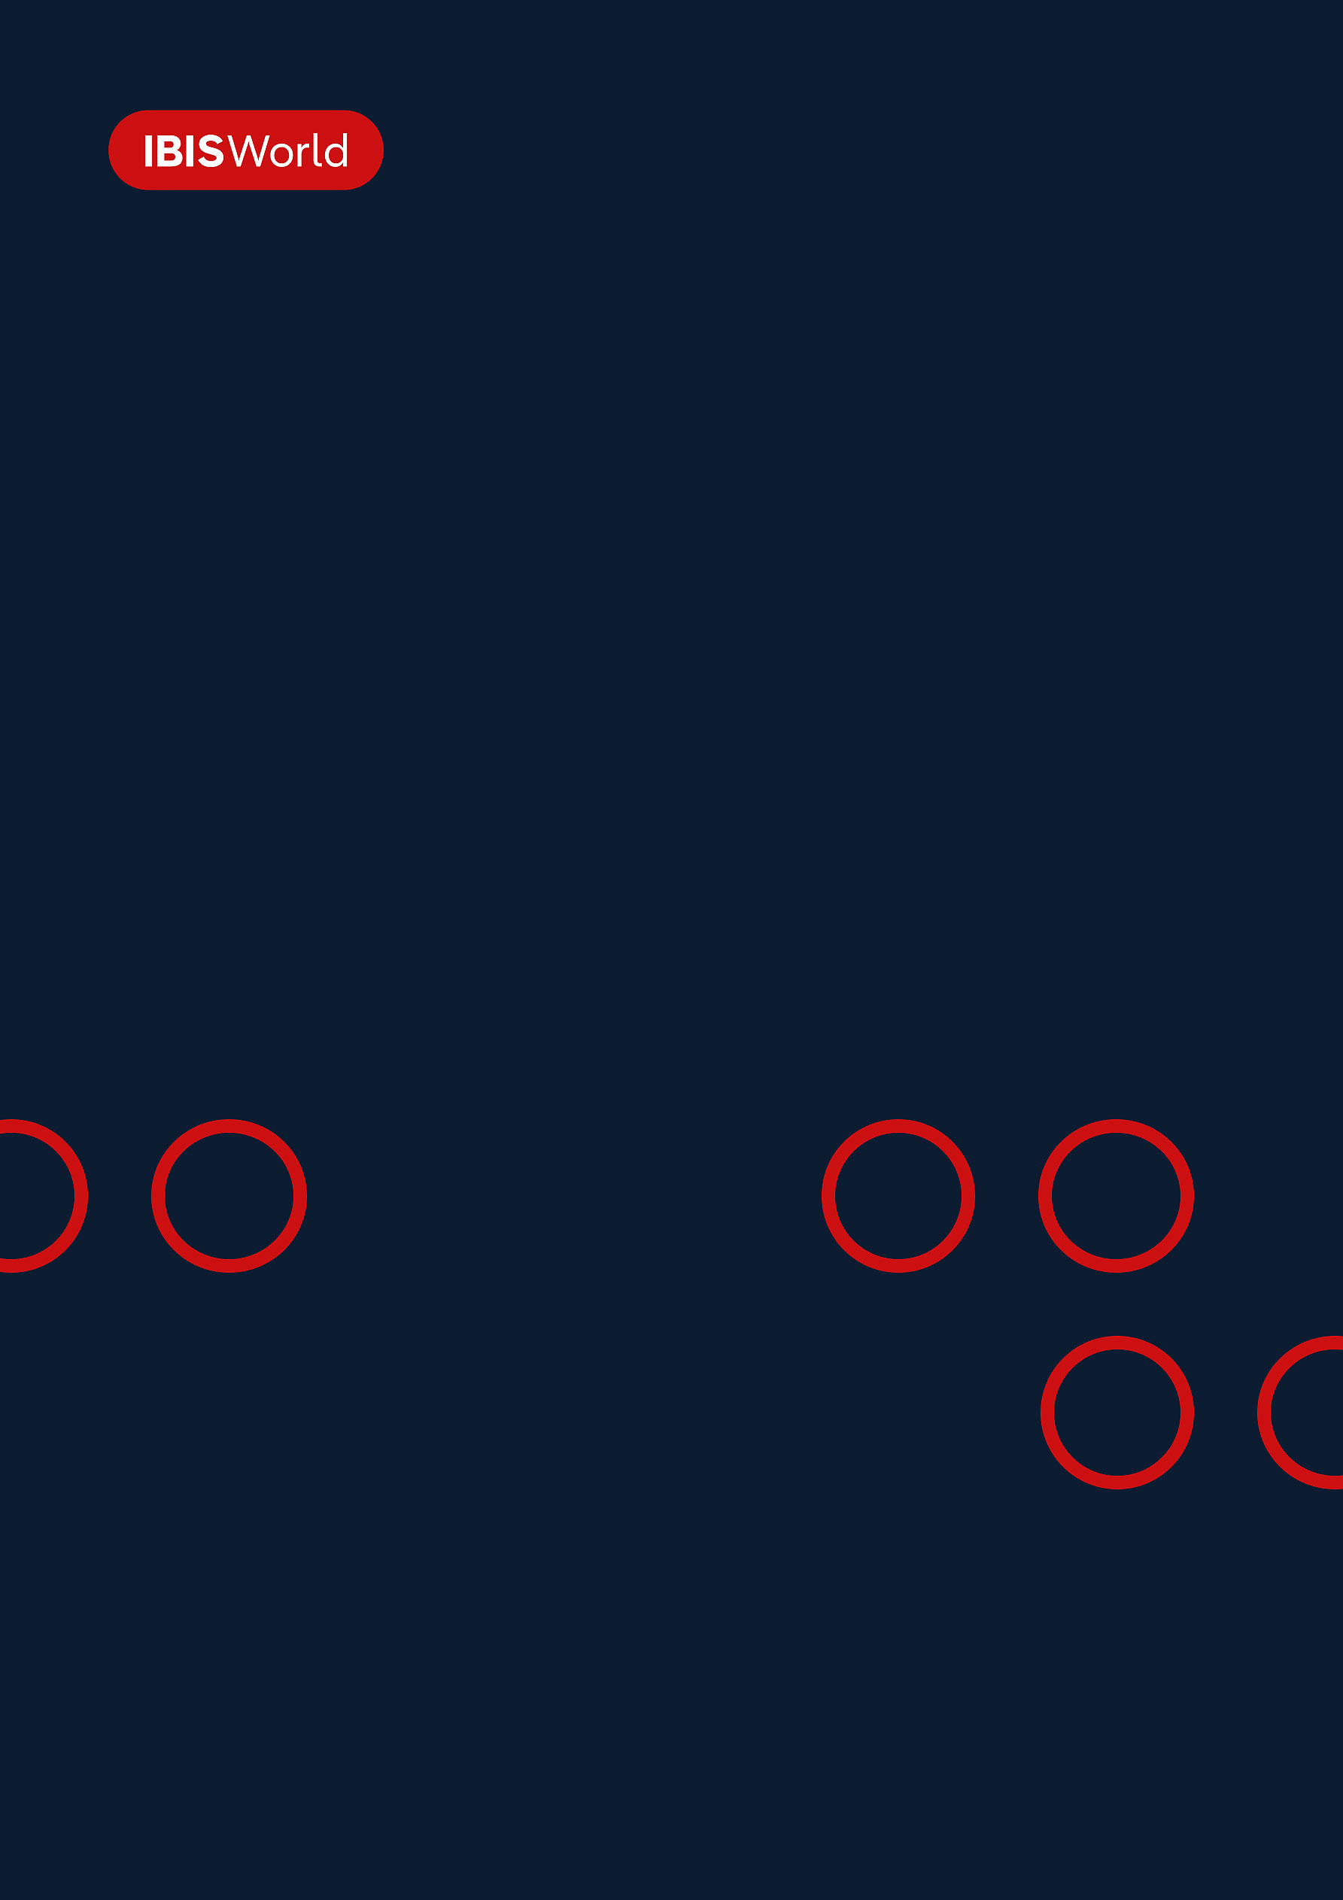
INDUSTRY REPORT
Global Marine & Container Terminal Operation
May 2026

About

IBISWorld
IBISWorld specializes in industry research with coverage on thousands of global industries. Our comprehensive data and in-depth analysis help businesses of all types gain quick and actionable insights on industries around the world. Busy professionals can spend less time researching and preparing for meetings, and more time focused on making strategic business decisions.

Table Of Contents | Standard

1. About 4
Codes 4
Definition 4
Related Terms 4
What's Included 4
Companies 5
Related Industries 5
Additional Resources 5
2. At a Glance 6
Key Takeaways 6
Products and Services 7
Major Players 8
Key External Drivers 9
Industry Structure 9
SWOT 10
Executive Summary 10
3. Performance 12
Highlights 12
Key Takeaways 12
Performance Snapshot 13
Outlook 22
Life Cycle 25
4. Products and Markets 26
Key Takeaways 26
Products and Services 26
Major Markets 31
International Trade 34
5. Geographic Breakdown 35
Key Takeaways 35
Business Locations 36
6. Competitive Forces 40
Key Takeaways 40
Concentration 40
Barriers to Entry 42
Substitutes 43
Buyer & Supplier Power 44
7. Companies 46
Key Takeaways 46
Market Share 47
Companies 48
8. External Environment 56
Key Takeaways 56
External Drivers 56
Regulation & Policy 60
Assistance 61
9. Financial Benchmarks 63
Key Takeaways 63
Cost Structure 63
Key Ratios 66
10. Key Statistics 68
Industry Data 68

1. About
https://my.ibisworld.com/gl/en/industry/H4913-GL/about

Codes
ISIC Rev. 4 | 5222

Definition
Companies in the Global Marine and Container Terminal Operation industry operate maritime terminals, including facility operation of docks, piers and wharves. Activities also include loading and unloading cargo from container ships (stevedoring), arranging paperwork for incoming shipments to meet customs requirements, operating a computer system to connect cargo with recipients and transferring cargo onto trucks and trains.

Related Terms

TWENTY-FOOT EQUIVALENT UNIT (TEU)
Used to measure container quantity/capacity.

ROLL-ON, ROLL-OFF (RO-RO)
Wheeled cargo such as automobiles, trailers, railroad cars.

LIFT-ON, LIFT-OFF CARGO (LO-LO)
Loading or unloading by the vessel's own cranes or by shore-based cranes.

JUST-IN-TIME (JIT) INVENTORY SYSTEMS
A strategy implemented to improve profitability by reducing inventory and purchasing raw materials needed for the immediate term only.

CELLULAR VESSEL
Ships used to efficiently store stacked containers with bracings to restrain cargo units.

STEVEDORING
The procedure of handling cargo as ships are docked, including both loading and unloading operations at the port.

THROUGHPUT
The amount of material or data that passes through a machine or system.

What's Included
- Marine cargo handling
- Navigational services
- Port and harbor operations

Companies
- DP World PLC
- PSA International Pte Ltd.
- CK Hutchison Holdings Limited
- AP Moller - Maersk A/S

Related Industries

Industries in the Same Sector
- Competitors:
  - Global Deep-Sea, Coastal & Inland Water Transportation
  - Global Airport Operation
- Complementors:
  - Global Ship & Boat Building
  - Global Airlines

International Industries
- Port & Harbor Operations in the US
- Port & Water Transport Terminal Operations in New Zealand
- Harbor & Port Operations for Freight in China

Additional Resources
- International Maritime Organization
- World Shipping Council
- US Census Bureau
- The Federation of European Private Port Companies and Terminals
- United Nations Conference on Trade and Development
- The World Bank Group

2. At a Glance
https://my.ibisworld.com/gl/en/industry/H4913-GL/at-a-glance
Revenue  $99.2bn  ’21-’26 ↑ 5.3 %  ’26-’31 ↑ 2.6 % | Employees  678k  ’21-’26 ↑ 4.6 %  ’26-’31 ↑ 2.5 % | Businesses  1,637  ’21-’26 ↑ 0.3 %  ’26-’31 ↑ 1.1 %
Profit  $15.0bn  ’21-’26 ↓ 2.9 % | Profit Margin  15.1%  ’21-’26 ↓ 7.6 pp | Wages  $25.8bn  ’21-’26 ↑ 8.2 %  ’26-’31 ↑ 2.6 %

Key Takeaways

Performance
- Bigger ships, conflict rerouting and LNG growth are all lifting terminal demand but straining capacity. Vessel upsizing, Red Sea diversions, and tight LNG markets are pushing more volume through select hubs, forcing operators to spend heavily on berths, cranes and specialized gas infrastructure.
- Pressure is mounting on ports and terminals to decarbonize and automate operations. While environmental investments strain short-term profit and US unions resist automation, those who adapt will set new efficiency and reputation benchmarks in international shipping.

Products and Markets
- Marine cargo handling services are crucial revenue drivers for ports. As global trade faces ongoing disruptions like the Red Sea crisis, these services have become even more valuable, with increased port congestion boosting demand and industry revenue.
- Containers and Ro-Ro traffic are anchoring more stable, diversified terminal demand. As the rerouted Red Sea trade boosts container flows into Europe, Africa and Asia, recovering passenger and vehicle movements on Ro-Ro routes give ports an additional, steadier revenue stream.

Products and Services
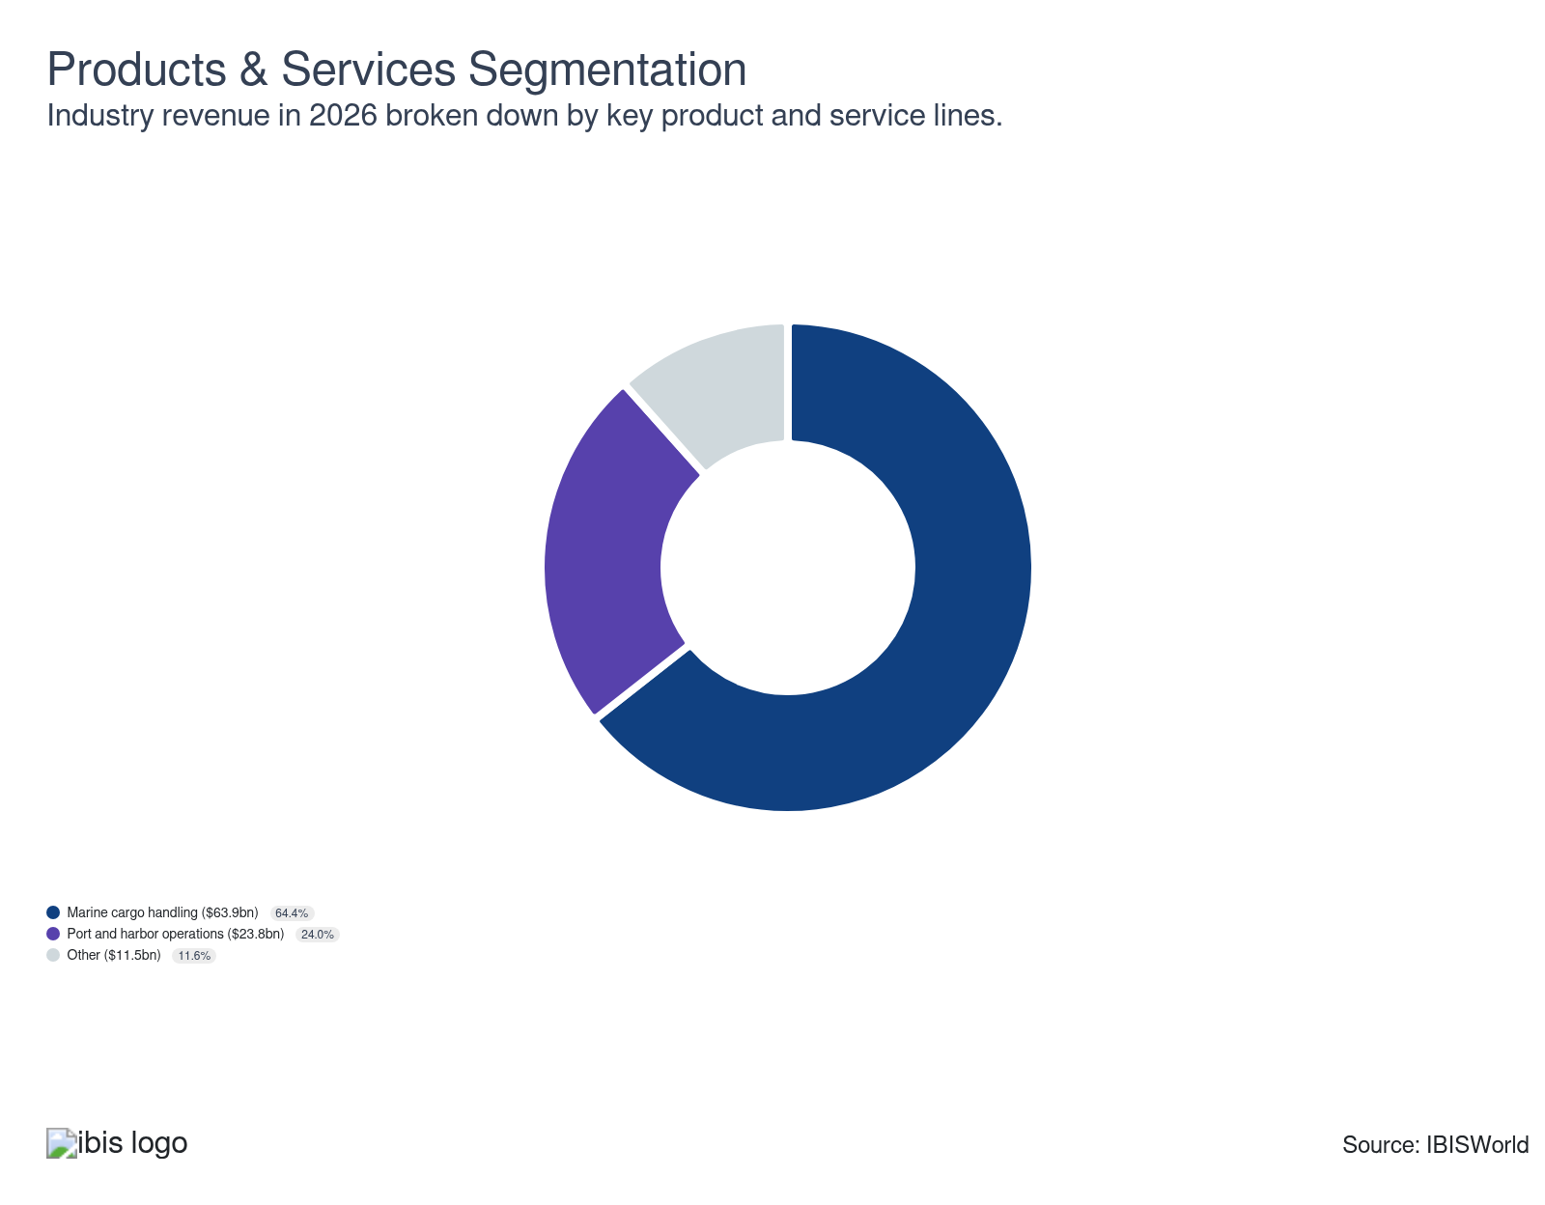

Major Players
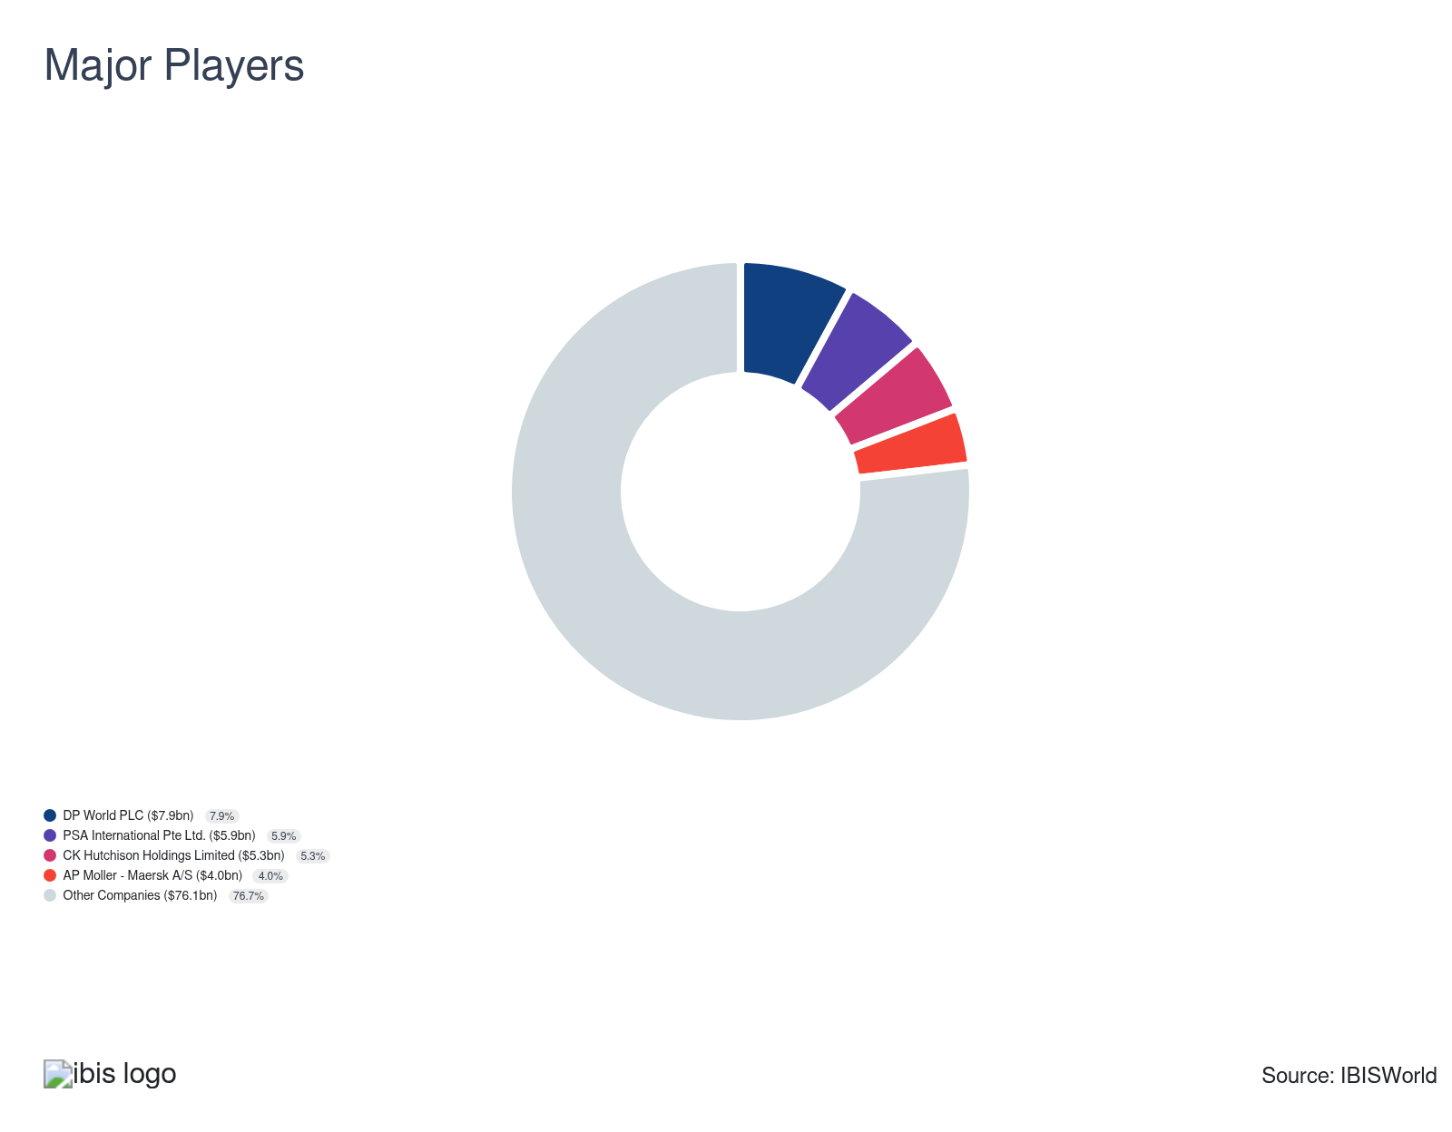

Key External Drivers
Key External Drivers | Impact
World GDP | Positive
Global consumer spending | Positive
Total value of world trade | Positive
GDP of mainland China | Positive
Global unemployment rate | Negative
GDP of the BRIC nations | Positive

Industry Structure
Characteristic | Level | Trend
Concentration | Low
Barriers To Entry | High | Increasing
Regulation and Policy | Moderate | Increasing
Life Cycle | Growth
Revenue Volatility | Moderate
Assistance | Moderate | Increasing
Competition | Moderate | Steady
Innovation | Low

SWOT
Strengths  High Profit vs. Sector Average  Low Customer Class Concentration | Weaknesses  High Volatility  High Product/Service Concentration  Low Revenue per Employee  High Capital Requirements | Opportunities  High Revenue Growth (2020-2025)  High Performance Drivers  Global consumer spending | Threats  Low Revenue Growth (2025-2030)  GDP of the BRIC nations

Executive Summary

Smooth sailing: Global marine terminals face rising volumes from bigger ships, Red Sea rerouting and LNG growth, while investing heavily in capacity, portfolio shifts and cybersecurity to manage congestion, protect operations and sustain profitability amid heightened risk.
Industry revenue growth was strong, despite major geopolitical and macroeconomic shocks. Red Sea disruptions forced carriers to divert Asia–Europe traffic away from Suez, driving higher call volumes at alternative hubs such as Spain and Singapore and prompting terminals to extend working hours and recommission retired capacity to manage unplanned surges. At the same time, a structural shift toward larger container vessels raised operating thresholds, pushing operators to fund berth extensions, yard expansions and larger ship-to-shore cranes, which increased capital intensity but enabled terminals to handle higher volumes. These dynamics supported robust top-line expansion as rerouting and vessel upsizing flowed through to throughput and handling income.
However, product mix and risk management choices also shaped overall performance. Rising LNG demand following the Ukraine crisis led businesses to acquire stakes in LNG import terminals in Europe and other strategic markets, adding long-lived assets tied to energy diversification and transition policies while boosting fee and handling income. Simultaneously, accelerated digitalization exposed terminals to more frequent and sophisticated cyberattacks, prompting operators to increase spending on multilayer cybersecurity systems, data protection and workforce training, while higher wage costs and sustained investment in larger cranes and expanded facilities weighed on profit even as volumes climbed. Taken together, these factors lifted industry revenue to an estimated $99.2 billion in 2026, implying a 5.3% CAGR through the end of 2026 and a 5.7% YOY increase in the year.
Looking forward, marine and container terminals face transformative operating conditions. While automation introduces significant efficiency opportunities, labor agreements on the US East and Gulf Coasts remain a barrier to wide-scale deployment. In this area, Chinese and other Asian gateway ports are quickly gaining a technological edge. There's growing pressure to comply with Scope 3 emissions regulations, likely fueling investments in battery-electric terminal equipment and low-emission infrastructure as ports and customers target decarbonization goals. The emergence of new corridors, such as the India-Middle East-Europe Economic Corridor, positions selected terminals to benefit from higher trade volumes but also requires advancement in digital customs and documentation processes. In parallel, ocean carrier alliances are expected to drive a shift to a hub-and-spoke model, boosting the importance and throughput of smaller feeder terminals aligned with the industry’s evolving network. These dynamics indicate continued growth, with forecasts projecting industry revenue to climb at a CAGR of 2.6% and generate $113.0 billion by 2031.

3. Performance
https://my.ibisworld.com/gl/en/industry/H4913-GL/performance

Highlights
Revenue  $99.2bn  2021-26 CAGR ↑ 5.3 %  2026-31 CAGR ↑ 2.6 % | Employees  678k  2021-26 CAGR ↑ 4.6 %  2026-31 CAGR ↑ 2.5 % | Businesses  1,637  2021-26 CAGR ↑ 0.3 %  2026-31 CAGR ↑ 1.1 %
Profit  $15.0bn  2021-26 CAGR ↓ 2.9 % | Profit Margin  15.1%  2021-26 CAGR ↓ 7.6 pp

Key Takeaways
- Bigger ships, conflict rerouting and LNG growth are all lifting terminal demand but straining capacity. Vessel upsizing, Red Sea diversions, and tight LNG markets are pushing more volume through select hubs, forcing operators to spend heavily on berths, cranes and specialized gas infrastructure.
- Pressure is mounting on ports and terminals to decarbonize and automate operations. While environmental investments strain short-term profit and US unions resist automation, those who adapt will set new efficiency and reputation benchmarks in international shipping.

Performance Snapshot
Revenue: | ↑ 2021-26 Revenue CAGR +5.3%
Revenue  $99.2bn  ’21-’26 ↑ 5.3 %  ’26-’31 ↑ 2.6 % | 2026 Revenue Growth  ↑ 5.7 % | Revenue Volatility  Moderate
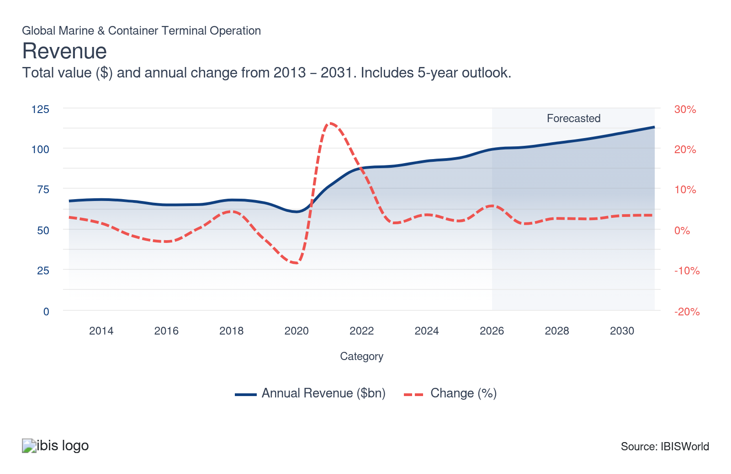
Employees: | ↑ 2021-26 Employees CAGR +4.6%
Employees  678k  ’21-’26 ↑ 4.6 %  ’26-’31 ↑ 2.5 % | Employees per Business  414  ’21-’26 ↑ 4.3 %  ’26-’31 ↑ 1.4 % | Revenue per Employee  $146k  ’21-’26 ↑ 0.7 %  ’26-’31 ↑ 0.1 %
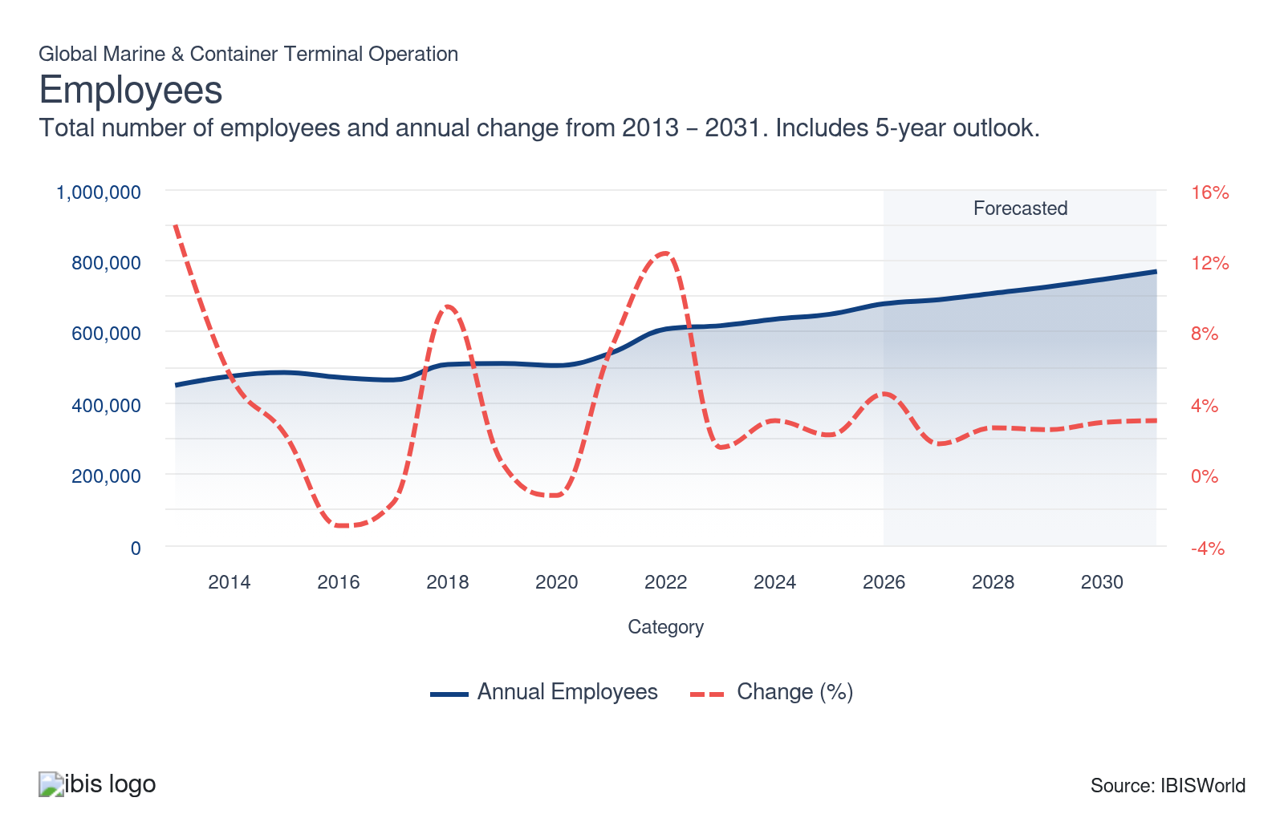
Businesses: | ↑ 2021-26 Business CAGR +0.3%
Businesses  1,637  ’21-’26 ↑ 0.3 %  ’26-’31 ↑ 1.1 % | Employees per Business  414  ’21-’26 ↑ 4.3 %  ’26-’31 ↑ 1.4 % | Revenue per Business  $60.6m  ’21-’26 ↑ 5.0 %  ’26-’31 ↑ 1.5 %
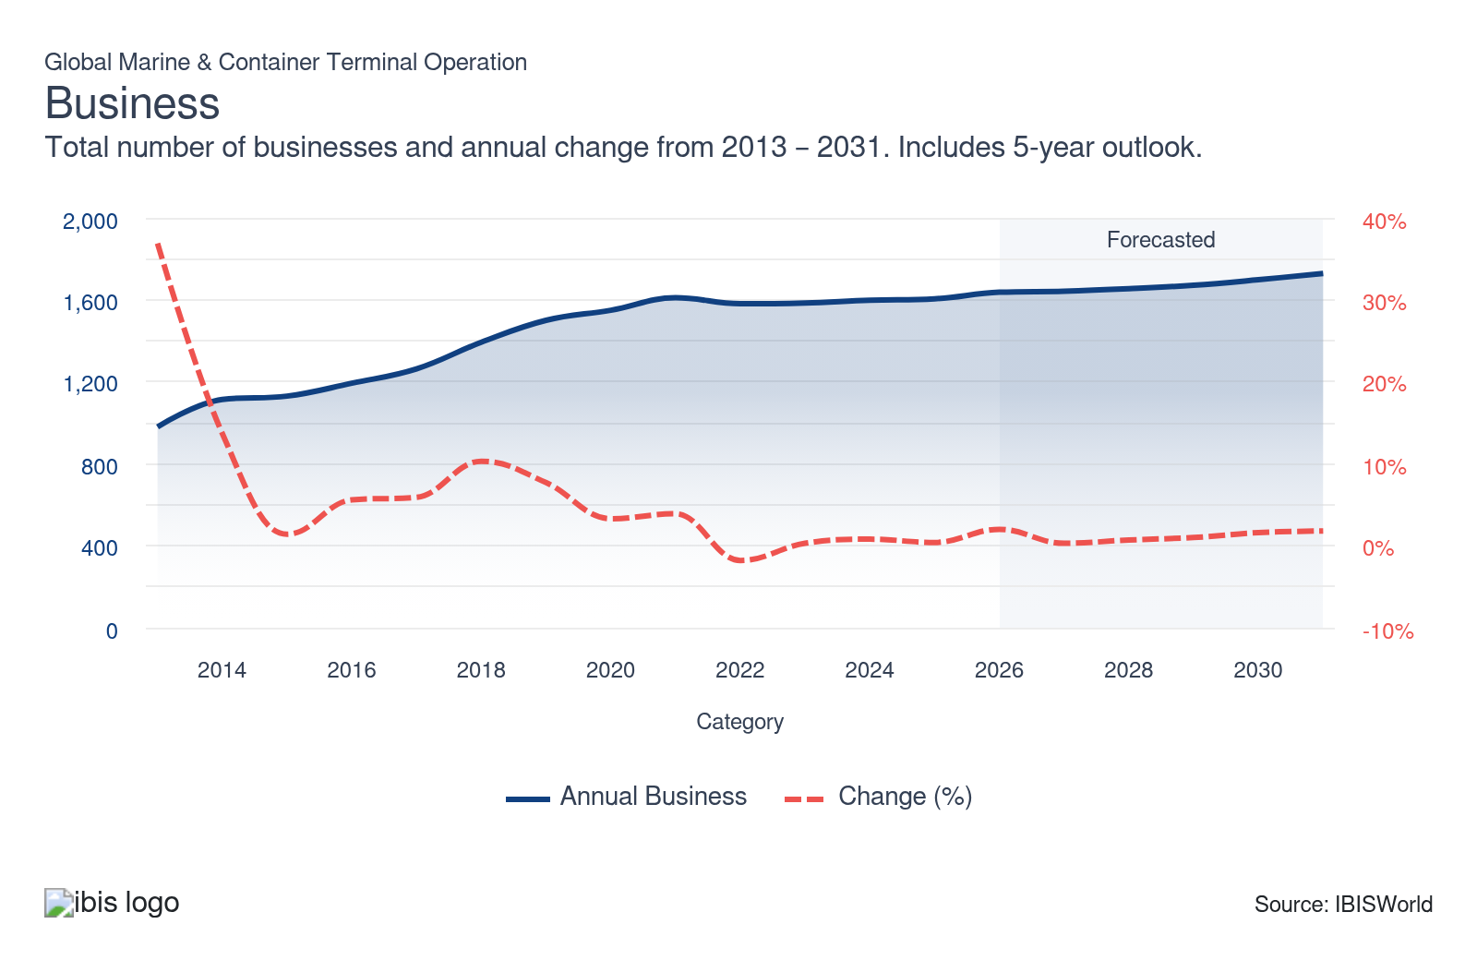
Profit: | ↓ 2021-26 Profit CAGR -2.9%
Total Profit  $15.0bn  ’21-’26 ↓ 2.9 % | Profit Margin  15.1%  ’21-’26 ↓ 7.6 pp | Profit per Business  $9.2m
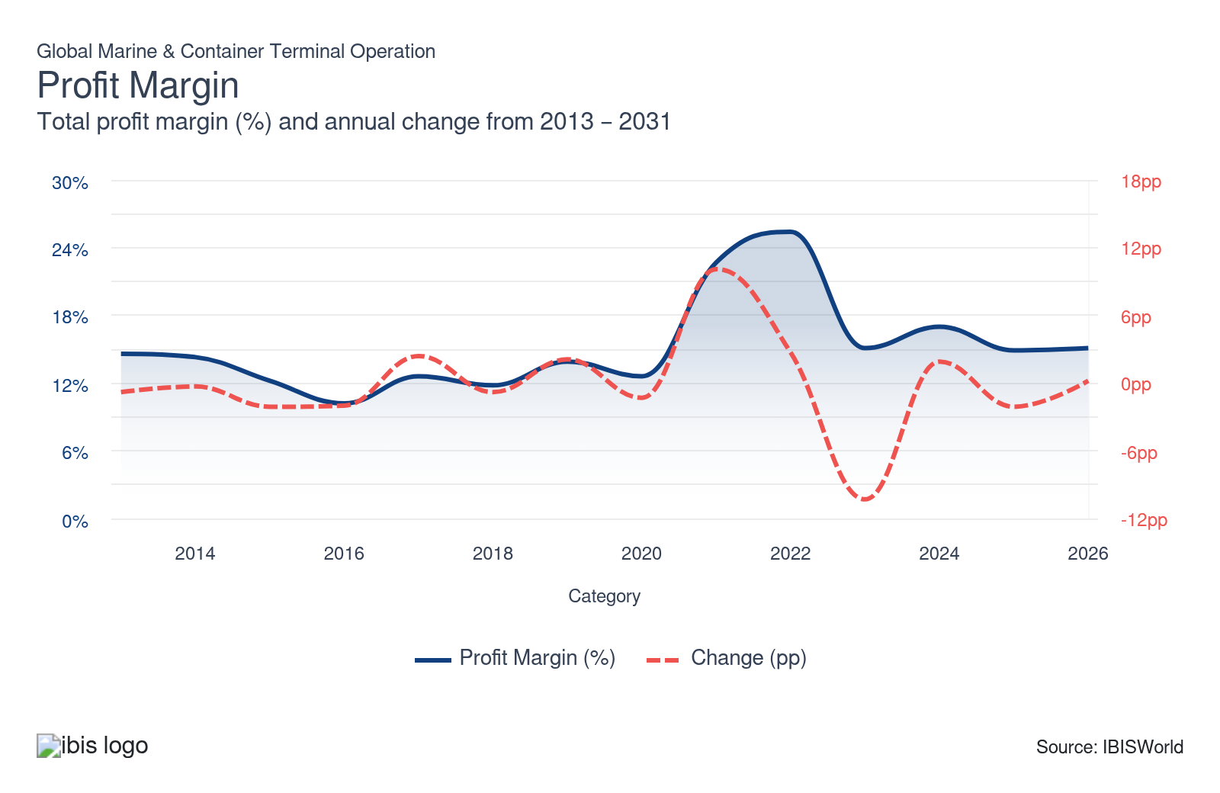
Current Performance
Current Performance

What's driving current industry performance?

Bigger ships and capacity upgrades are driving container segments
- Global marine and container terminals are adapting to a structural climb in ship size, which is raising operational demands. World Bank analysis using MDS Transmodal data indicates that in the five years to the first quarter of 2025, the average size of the largest ships calling at each port grew at a compound annual rate of about 12.0%, adding stress to ports’ cargo-handling capabilities and requiring longer berths, deeper quays and more powerful equipment to turn vessels efficiently.
- Fleet expansion plans suggest that pressure from large vessels will intensify through the medium term. Veson Nautical reports that global ship orders were up 76.0 percent year over year in 2024, with ultra-large container vessels (ULCVs) and New Panamax ships dominating newbuild activity and scheduled for delivery through 2028, meaning terminals will increasingly contend with larger ships as a regular feature of call patterns rather than an exception.
- Capacity strain is now a prominent operational risk across the sector. In a 2026 International Association of Ports and Harbors (IAPH) survey, 74.0% of ports and terminals cited facilities and infrastructure operating at or near their limits as the third-largest risk they faced, underscoring how rising vessel sizes and volumes are stretching existing assets and elevating congestion risk. In response, 64.0% of respondents reported investing in core port infrastructure such as quay walls and terminal expansions, indicating that operators are committing capital to relieve bottlenecks and safeguard service quality.
- Specific expansion projects are already lifting throughput and financial performance. DP World has completed a $400.0 million expansion at the Port of Callao in Peru, increasing container handling capacity by 80.0 percent and enabling the terminal to handle three vessels or two mega-vessels simultaneously, with volumes surpassing 2.0 million TEU in 2025 and contributing to double-digit revenue growth in its Americas operations.
- Equipment upgrades are reinforcing these infrastructure investments. The Port Equipment Manufacturers Association reports that 2024 demand was dominated by transshipment and regional hub ports buying ship-to-shore cranes capable of handling ships stowing containers up to 25 rows wide, with the global stock of cranes with lift heights of at least 40 meters rising from 133 units in 2023 to 179 in 2024, supporting higher throughput and enabling operators to capture returns on recent capacity spending.

Red Sea conflict rerouting is reshaping supply chain networks
- The Red Sea crisis that escalated in late 2023 from the Israel–Hamas conflict has driven Houthi attacks on commercial vessels transiting the Red Sea, prompting shipping lines to reassess security risk and divert traffic away from the region. Companies have shifted vessels away from traditional Red Sea–Suez lanes and the Suez Canal Authority reported that ship transits fell 30.0 percent in July 2024 compared with July 2023, highlighting the severity of the disruption to this corridor. Marine Benchmark data for December 2023 to February 2024 indicate that many operators instead used the longer route via South Africa, substantially extending Europe–Asia voyages and triggering a rapid reconfiguration of established maritime supply chains.
- These route changes are driving schedule instability and congestion at major transshipment hubs. In Singapore, Port of Singapore data cited by Minister for Transport Chee Hong Tat show that about 90.0% of vessels arrived outside their allocated berthing windows in 2024, up from 77.0% in 2023, reflecting longer, more variable voyages that are pushing ships off schedule. The resulting bunching of arrivals has complicated berth planning and yard management, with more ships competing for limited quay and storage space at short notice.
- Western Mediterranean ports, particularly in Spain, have seen higher volumes as traffic that might otherwise move via Red Sea–Suez routings shifts westward. The Port of Barcelona reported an 18.5 percent year-over-year climb in container volumes in 2024, indicating that more Asia–Europe and transshipment flows are being handled through Spanish gateways. Jordi Torrent, head of strategy at the Port of Barcelona, has noted that terminals have extended land-side working hours to process the additional volumes and maintain service levels under this increased demand.
- Operators are accelerating capacity adjustments to cope with these trends, although this is increasing cost pressure. In Singapore, PSA International has reactivated berths and yard space at Keppel Terminal, lifting the port’s weekly handling capacity from 770,000 TEU to 820,000 TEU and supporting a 5.5% year-over-year climb in container throughput and higher revenue in 2024. However, these gains have come alongside higher capital and labor costs, as ports such as Singapore and Barcelona invest in additional assets and staffing, weighing on profitability even as throughput and top-line performance improve.

LNG-led investment and portfolio shifts are driving terminal operators
- Tight global liquefied natural gas (LNG) supply and elevated utilization are underpinning investment decisions in marine and container terminal operations. A 2026 study by the Oxford Institute for Energy Studies reports that average utilization at LNG export plants reached about 97.0% between 2021 and 2025, reflecting how capacity constraints and limited new liquefaction infrastructure have intersected with strong post-Ukraine war LNG demand as countries seek to diversify away from Russian pipeline gas and support energy transition goals.
- LNG demand has rebounded since 2023, supported by industrial activity in Asia and Europe and by buyers’ efforts to secure flexible seaborne gas supply. The International Energy Agency has highlighted that LNG consumption began rising again in 2023 and into 2024 as buyers recalibrated away from Russian flows and increased imports from alternative suppliers such as the United States, reinforcing the commercial case for additional LNG import capacity and associated marine terminal infrastructure.
- These fundamentals are encouraging operators and investors to acquire and expand LNG terminals as strategic growth platforms. In 2023, Vopak acquired a 50.0% stake in the EemsEnergyTerminal, an LNG import facility in the Netherlands that was developed in 2022 in response to the Ukraine crisis as Europe sought alternative gas import routes, while VTTI and Snam completed the acquisition of the Adriatic LNG import terminal in Italy from ExxonMobil in 2024. Vopak has attributed part of its 2024 EBITDA growth to its EemsEnergyTerminal stake, indicating that LNG assets are contributing meaningfully to earnings.
- Portfolio rebalancing toward gas and industrial terminals is also shaping performance and capital allocation strategies. Vopak’s 2025 report notes that the company has divested about EUR 214 million of oil and chemical distribution assets while pursuing greenfield investments in gas and industrial terminals, including projects in South Africa and Australia, signaling a deliberate shift toward LNG and related infrastructure as key profit and growth drivers for marine and terminal operators over the coming years.

Cyber risks and security investment are leading to investment growth
- Cyberthreats have become a material operational and financial risk for ports and terminals. In Jones Walker’s 2022 Ports and Terminals Cybersecurity Survey, 90.0% of US port and terminal respondents said they felt prepared for cyber incidents, yet 74.0% reported their systems or data had been the target of an attempted or successful breach in the prior year, highlighting a significant gap between perceived readiness and actual exposure. RightShip has similarly reported that about 50.0% of cyberattacks on ships in 2022 occurred while vessels were at or near ports and terminal boundaries, underscoring the vulnerability of the port interface.
- Attack frequency and sophistication are rising as the sector digitizes operations. Maritime cybersecurity firm CYTUR notes that maritime ransomware incidents increased from 156 cases in 2024 to 372 cases in 2025, with large port terminals identified as prime targets, reflecting attackers’ focus on high-value, highly networked facilities. Analysis from the World Economic Forum and the Center for Strategic and International Studies (CSIS) stresses that expanding digital “attack surfaces” in interconnected port systems raises the risk of disruptions to vessel arrival management, equipment deployment and cargo flows, with potentially severe economic consequences if successful attacks scale across networks.
- In response, operators are increasing cyber-related capital and operating expenditure as part of broader security programs. DP World has announced a $90.0 million port security investment at its Dominican Republic terminal, including an estimated $1.0–1.5 million dedicated to multilayer cybersecurity protections, signaling that cyber resilience is now embedded in physical security and infrastructure budgets.
- Some large operators are pairing technology investments with workforce-focused risk management. Adani Ports and Special Economic Zone (APSEZ) in India, which operates a global port portfolio, reported that by 2024, it was regularly training employees on cybersecurity awareness and had deployed tools such as Cloud Security Posture Management and ransomware-protected backup solutions. APSEZ disclosed that it recorded zero information security or data breach incidents in 2025, extending a clean record that’s been in place since 2021, suggesting that sustained investment in systems and training can reduce realized cyber incidents even as sector-wide threats climb.

What influences industry volatility?

Holiday shipping surges drive volatility for the industry
- Revenue volatility spikes ahead of major holidays. Ahead of events like Lunar New Year and Christmas, cargo volumes are shipped to meet a predictable rise in consumer demand. For example, US import volumes from China jumped 10.6% from December 2024 to January 2025 and saw a similar 11.0% increase across the same period a year prior, as reported by Descartes Datamyne.
- These influxes challenge terminals, creating logistical congestion and inviting revenue opportunities. Ports must manage bottlenecks by bringing on extra seasonal workers to move heightened volumes efficiently. Although the sector successfully thrives on substantial revenue during these peaks, the overwhelming loads increase the risk of cargo backlogs, which can delay shipments and strain port infrastructures, especially when too many arrivals cluster over a limited timespan.

Typhoon seasons and hurricanes create revenue challenges for global port operations
- Extreme weather events such as typhoon seasons and hurricanes force major Asian container terminals, including Shanghai, Ningbo and Hong Kong, to temporarily shut down or operate at reduced capacity for staff safety, disrupting planned ship schedules. Severe delays like those reported during Typhoon Pulasan in 2024 often leave ships stranded for extended periods, resulting in heavy vessel congestion.
- These operational slowdowns typically generate periods of intense, clustered strain on port resources as vessels queue to unload cargo quickly before conditions worsen or rival ports attract the ships. Terminal businesses face mounting stress balancing efforts to clear cargo rapidly against the potential loss of business. Revenue shrinks during shutdowns, such as those prompted by Typhoon Talim in Hong Kong, even as short-term congestion sometimes drives attention to services in play during these volatile peak disruptions.
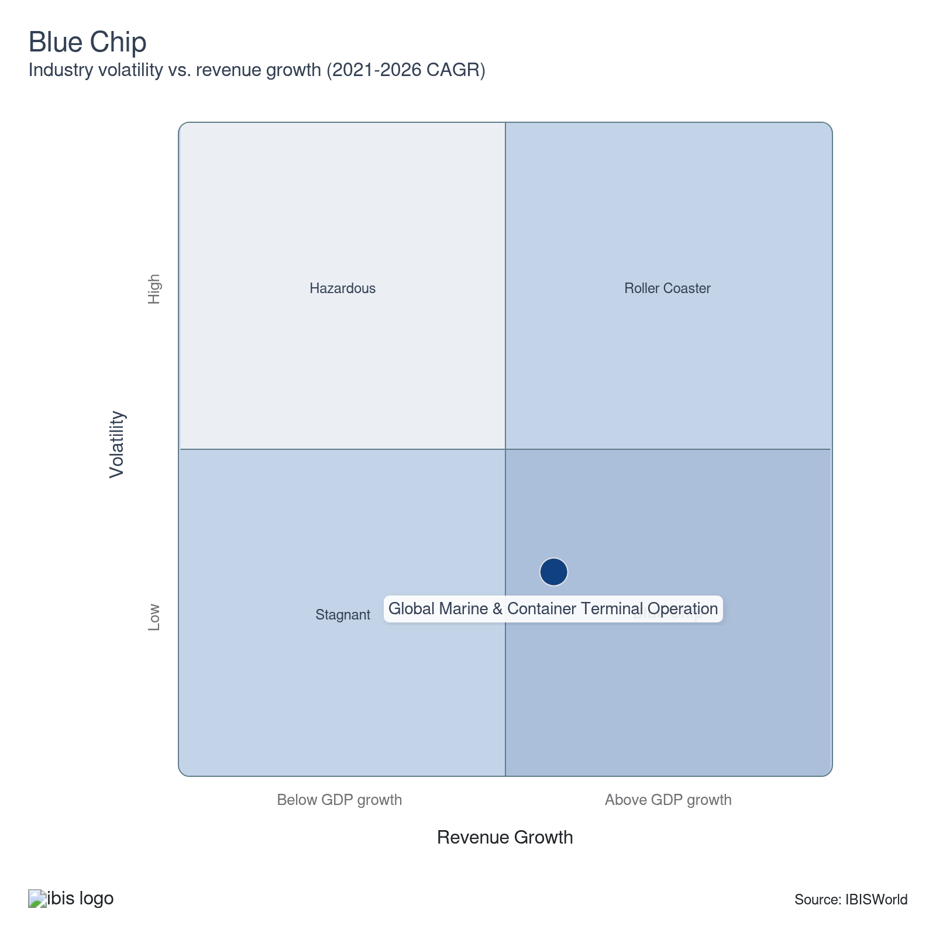

How do successful businesses overcome volatility?
Expand and curtail operations rapidly in line with market demand
Cargo volumes fluctuate considerably based on seasonal, economic and weather conditions. The ability to adjust throughput capacity and staffing levels in response to these patterns increases marine terminals’ efficiency and competitiveness.
Adapt quickly to changing regulations
Port terminal operators must stay abreast of regulatory conditions that may affect their operations. Agility is key; for example, they will need to quickly establish connections with new shipping companies in allied nations in the event their home government imposes sanctions on imports from major clients.
Outlook | ↑ 2026-31 Revenue CAGR +2.6%

What's driving the industry outlook?

Container alliances reshape competitive landscape for global terminal operators
- Following the launch of the Gemini Cooperation, a new alliance between Maersk and Hapag-Lloyd that began in 2025, the global marine shipping industry is moving toward a pronounced hub-and-spoke model. Under this system, centralized “hub” terminals managed by key players—such as Maersk’s APM Terminals—will marshal the mainline traffic. Containers from smaller, regional “spoke” ports feed into these main hubs via a network of feeder vessels. The rise of this model poses both new gateways and significant roadblocks for smaller and regional terminal operators, whose ability to capture a share of ongoing cargo flows depends largely on formal inclusion in the alliance’s service agreements.
- While the hub-and-spoke configuration centralizes much of the cargo volume and control within select terminals, it amplifies feeder service activity demand. Many emerging markets and smaller ports, though not principal hubs, see a potential uptick in relevance as their role in import and export activities aligns with the needs of major alliances. This shift injects heightened competition among smaller terminals; they view contracts from large-scale alliances like Gemini as securing consistent throughput, revenue streams and industry prominence. Terminals unable to secure these contracts risk being left behind, intensifying efforts to differentiate themselves across service reliability, technological capability and operational efficiency.
- Pursuing a partnership with major alliances places additional cost burdens on smaller terminals. With Gemini Cooperation targeting an ambitious 90.0% schedule reliability, contracted terminals will face increased scrutiny regarding workforce quality, operational safety and responsiveness. To meet these demands, smaller players must invest in employee training, equipment maintenance and regular performance reviews, pressuring their short-term profitability. However, entering the service loop of an expansive alliance may offer longer-term advantages in operational scale, network guarantees and potential specialization opportunities. Whether these terminals can translate investment into sustainable contracts remains a key variable in the years ahead.

Infrastructure investments and digital connectivity initiatives shape future of global terminal operations
- The proposed India-Middle East-Europe Economic Corridor (IMEC) could significantly impact global marine and container terminal operations by directly linking major markets across South Asia, the Middle East and Europe. If it moves forward, the corridor would establish a multi-modal trade route from key Indian ports like Mumbai or Mundra to Piraeus in Greece, passing through the UAE and Israel. Early government commitments, such as India’s approval of the Vadhavan Port (set to open by 2029), indicate the growing importance of newer, larger ports capable of handling increased traffic and supporting intercontinental flows. Any port incorporated into this network stands to benefit from heightened activity and revenue, while competitors risk missing out on the surge in regional trade.
- In 2024, India and the UAE launched a Virtual Trade Corridor agreement to accelerate digital paperwork and port system coordination, creating a more streamlined trade process. Ports seeking to join emerging corridors must integrate digital platforms (such as the MAITRI system connecting Indian and UAE data for customs and trade) into their operations. These platforms are expected to reduce clearance times, improve data accuracy and create a transparent trading environment. However, terminals will need to increase IT investment and overhaul in-house software to ensure compatibility with these cross-border systems, exerting short-term budgetary pressure even as they seek to capitalize on rising trade volumes.
- Moving forward, marine and container terminals need to make structural and digital investments to remain relevant in a world shaped by interconnected, tech-enabled corridors. Access to major trade streams is no longer determined by geography alone but increasingly by each facility’s integration into regional data networks and capacity for high-volume throughput. While these adjustments may temporarily limit industry profitability because of costly IT upgrades and infrastructure expansions, they also open up greater long-term revenue potential by better positioning ports to serve the evolving demands of global commerce.

Decarbonization requirements at ports push terminals to invest and adapt
- In 2024, the International Association of Ports and Harbors surveyed that nearly 58.0% of its member ports, which collectively manage almost 60.0% of global seaborne container trade, have established carbon neutrality targets for 2050. This trend is putting significant pressure on terminals at these ports to align with similar goals. Nearly 29.0% of their ports specifically plan to regulate Scope 3 emissions, which include indirect emissions from tenants like terminal operators. This fragmentation approach presents complexities for terminals as they face an evolving landscape of environmental expectations.
- Terminals operating at ports poised to impose Scope 3 standards now face stricter oversight regarding their emissions. Compliance with such frameworks has become vital for terminals to ensure the renewal of leases and continued business, heightening the importance of robust regulatory strategies and emissions management practices tailored to meet ports’ sustainability targets.
- The industry must allocate substantial capital to green technologies such as battery-electric yard tractors and low-emission cranes to comply. Since equipment like this is classified as an indirect emission source, its upgrade often falls directly to tenants. This dynamic imposes incremental costs on terminal operations, prompting companies to weigh upfront investments against long-term operating licenses and competitiveness. While instrumental for compliance, these outlays are expected to temporarily strain terminal profitability.
- Not all decarbonization-related investments come solely from terminal budgets. Funding usually involves ports, terminals and shipping lines in joint efforts for major projects like onshore power systems, which provide ships at berth access to the electrical grid and minimize docked vessel emissions. Collaborative investments enable stakeholders to collectively manage compliance burdens, though cost distribution varies by region and project. Ultimately, terminals will endure a mixed impact. At the same time, investments in operating equipment will increase direct costs; infrastructure projects aligned with broader regulatory timelines can cushion such impacts through port-led financial collaboration.

Automation pushes global container terminal efficiency, challenging US competitiveness
- The industry is seeing a swift and significant shift toward automation worldwide, with the Asia-Pacific region at the forefront. A 2022 study by the METRANS Transportation Consortium confirms that 63 container terminals have moved to semi- or fully automated systems. China is the global leader globally; its Ministry of Transport reports that the country has constructed 52 automated container and bulk cargo terminals as of January 2025. These advancements enable Chinese ports to achieve exceptional operational efficiency and fast vessel turnaround times, highlighted by Qingdao Port setting a world record in 2025 for single quay crane productivity at 60.9 TEUs per hour.
- In contrast, automation faces significant barriers in the United States, especially along the East and Gulf Coasts, where the International Longshoremen’s Association (ILA) represents the main unionized workforce. In early 2025, the ILA negotiated an extension to its contract, securing wage increases and maintaining strong prohibitions against fully automated terminals or even semi-automated equipment without explicit union approval that jobs and wage protections would not be harmed. These restrictions extend through 2030, escalating challenges for US terminals seeking to adopt efficiency-boosting technologies under the current labor agreement.
- US terminals' inability to fully adopt automation means the industry’s wages and operating costs remain comparatively high, making competing with rivals in regions embracing robotic operations and autonomous vehicles harder. Instead of replacing labor, many US terminals embarking on any automation must treat it as a supplemental measure with strict limits. That approach likely cushions short-term job security but results in fewer productivity gains and keeps costs static. The divergence in operating models may place lasting pressure on US-based ports' profit and global standing relative to those in China and other automation-focused countries.
- The presence of highly automated and traditionally operated terminals creates a starkly mixed outlook for the sector. While ports prioritizing automation could continue to absorb higher cargo volumes efficiently and safely, facilities restricted by labor and regulatory constraints may be unable to set competitive operating benchmarks or achieve record productivity. Segment performance predictions reflect these dynamics: while port and harbor operation segments embracing automation are likely to grow moderately, marine cargo handling sectors tied to more restrictive labor environments could endure stagnation. In the broader context, China and other automation leaders will likely boost operational efficiency and cost advantages, driving a deeper divide in global port competitiveness as technological transformation pushes ahead.
Life Cycle | Growth

Why is the industry growing?

Contribution to GDP
The industry is growing faster than global GDP, highlighting its increasing importance. Port operations are crucial in the modern economy as they enable and expand international trade. Maritime trade remains essential and its significance continues to rise as shifting geopolitical landscapes alter trade routes. These changes have emphasized the need for efficient port terminals, which are now more vital than ever for supporting the world’s economy.

Market Saturation
The market is experiencing growth as realignment and changes in domestic trade habits drive increased investment in ports. These developments position ports as emerging hotspots for economic activity. Unexpected regions have gained attention and significance within the industry, largely due to geopolitical factors that have expanded their roles and generated substantial industry activity.

Innovation
Purchases of advanced machinery designed to lift containers, powered by sustainable fuel sources, have been made. These investments have enabled the industry to save on costs through more efficient solutions. Efforts like these have driven innovation in the industry, particularly in certain areas.

Consolidation
The industry is characterized by substantial regional concentrations, with many terminals clustered in specific geographic areas. Terminal projects also tend to have long development timelines. These factors challenge larger companies, making it difficult for them to expand their operations and effectively consolidate the industry.

Technology & Systems
Port operation services have a low to moderate degree of technological change. Operators must have the proper communication software to communicate with all companies transporting goods. In addition, operators must have the appropriate technological equipment to service each vessel as quickly and efficiently as possible.

4. Products and Markets
https://my.ibisworld.com/gl/en/industry/H4913-GL/products-and-markets
Largest Market  $63.9bn  Marine cargo handling | Product Innovation  Low

Key Takeaways
- Marine cargo handling services are crucial revenue drivers for ports. As global trade faces ongoing disruptions like the Red Sea crisis, these services have become even more valuable, with increased port congestion boosting demand and industry revenue.
- Containers and Ro-Ro traffic are anchoring more stable, diversified terminal demand. As the rerouted Red Sea trade boosts container flows into Europe, Africa and Asia, recovering passenger and vehicle movements on Ro-Ro routes give ports an additional, steadier revenue stream.

Products and Services
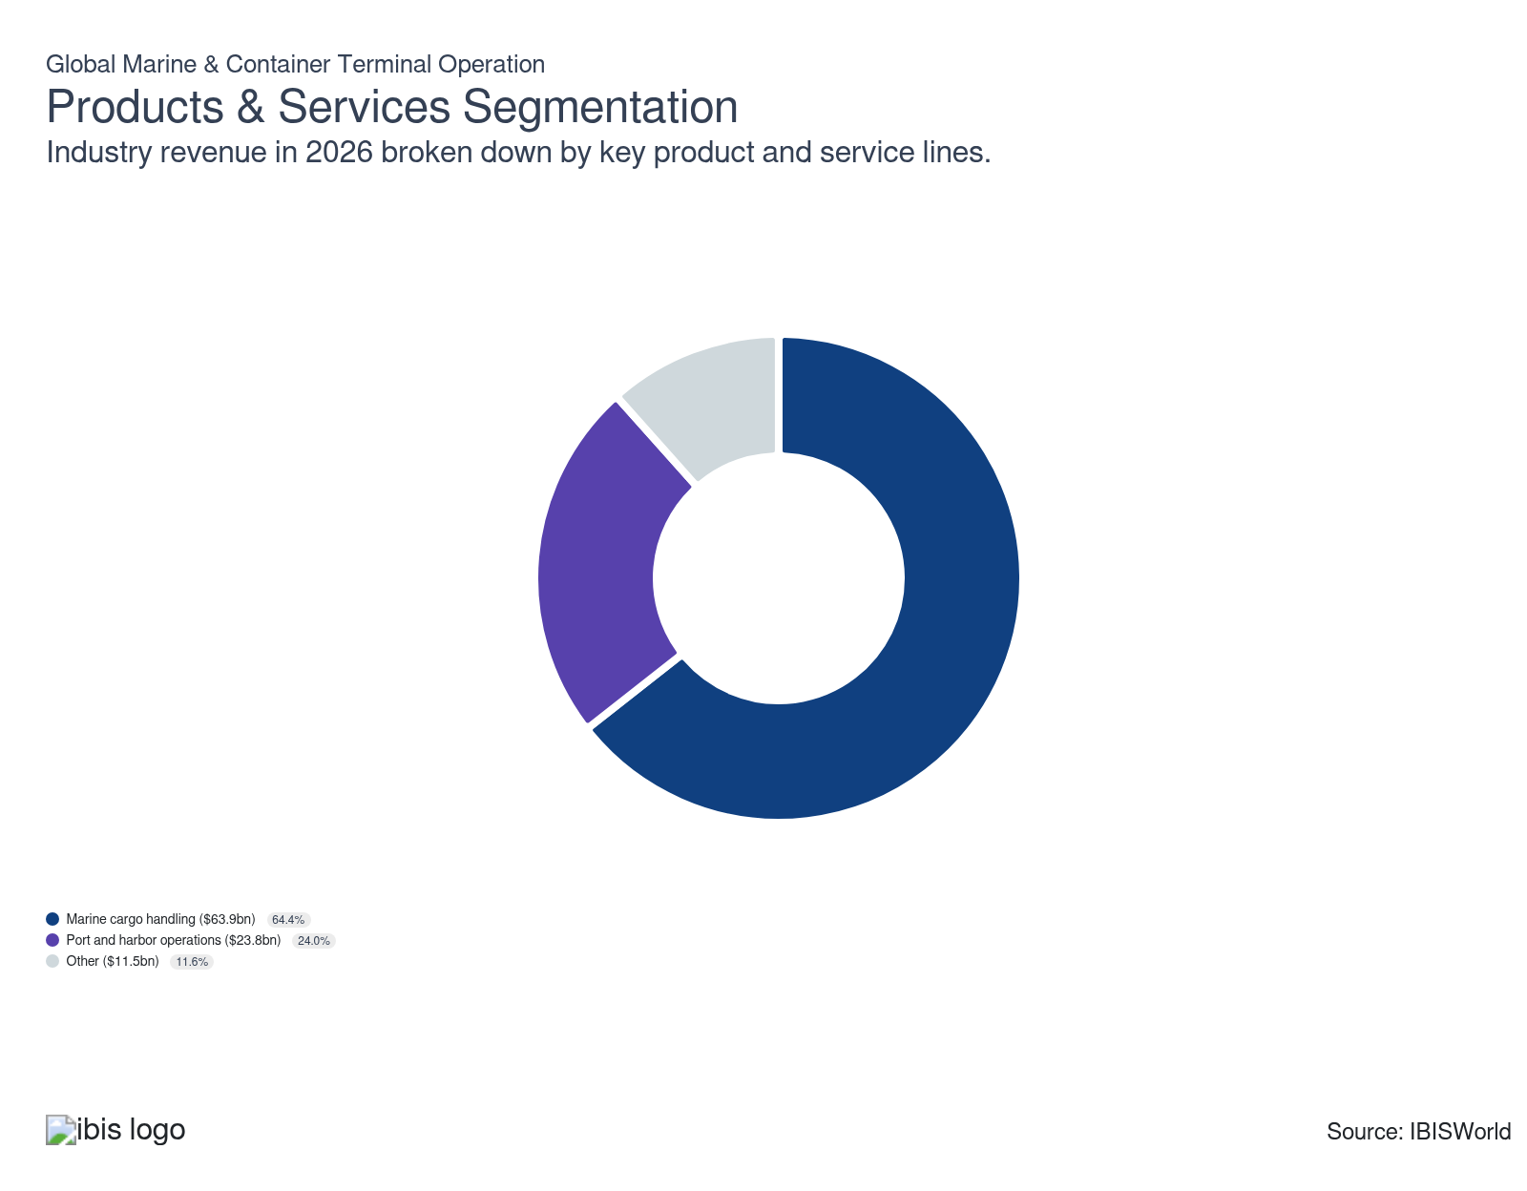

How are the industry’s products and services performing?

Geopolitical rerouting and port congestion are amplifying demand for marine cargo handling services
- Marine cargo handling, which covers the loading, unloading, transfer and temporary storage of cargo between ships and land-based transport, has benefited from the compound disruption of the Strait of Hormuz crisis (from February 2026) and the second consecutive year of Houthi-driven Red Sea diversions. Together, these events have rerouted a substantial share of global container and bulk trade via the Cape of Good Hope, extending voyage durations and increasing cargo volumes handled at alternative hub ports. At the same time, terminals with concentrated Gulf or Suez call schedules absorb throughput shortfalls.
- Port-level throughput records across multiple geographies confirm that handling volumes accelerated through 2025 and into 2026. With 44.66 million twenty-foot equivalent units (TEUs) recorded in 2025, up 8.6% year-on-year, Singapore's port authority was named the world's leading container port by DNV-Menon. According to International Container Terminal Services (ICTSI)'s Q1 2026 report, consolidated volumes surged sharply, with its newly operational Durban Container Terminal (DCT) Pier 2 a primary contributor.
- Emerging-market terminal expansion is driving incremental cargo-handling volumes beyond established hubs, confirming that rerouting has broadly distributed volume gains across alternative geographies and compressed the revenue advantage previously concentrated at Suez-proximate terminals. Nigeria's Lekki Deep Sea Port grew throughput 77% year-on-year to achieve a 40.6% national share, becoming the country's highest-volume terminal.
- Terminal operators have responded by accelerating capacity deployment at congestion-pathway ports. PSA International launched Phase 2 of the automated Tuas Port in Singapore in early 2026, and ICTSI's 25-year partnership with Transnet at Durban aims to climb throughput from 2.0 million to 2.8 million TEUs annually, with crane productivity improvements supporting the expanded target.

Port and harbor operations maintain revenue share as bulk trade and congestion sustain docking demand
- Port and harbor operations include a variety of activities, one of the main ones being docking ships. Terminals charge ships to use their docks and facilities, generating significant revenue from these fees, second only to other sources, such as cargo handling. Many vessels lease dock space for long periods and ports often set higher rates to manage docking space efficiently and prevent ships from overstaying. This helps maintain a steady flow of incoming vessels and discourages congestion.
- Harbor congestion at European hub ports, including Rotterdam, Hamburg and Antwerp, which experienced two-to-seven-day vessel wait times in Q1 2026, has validated higher docking fee schedules. Ports managing vessel queues in this environment face both a revenue opportunity and an operational cost pressure, as longer berth occupancy raises per-vessel handling costs alongside fee income.
- Port authorities investing in operational efficiency are capturing a disproportionate share of the segment's value. India's Sagarmala program has cut vessel turnaround time from 96 hours in 2014 to 49.5 hours in 2025 through sustained government-backed infrastructure investment. This structural improvement increases berth throughput and fee revenue per unit of port time, offering a replicable efficiency model for port authorities seeking to maximize revenue per berth slot.

Rerouting-driven maintenance demand and automation investment are deepening other vessel services revenue
- Other vessel services, including dry dock repairs, hull maintenance, propeller servicing, instrumentation overhauls, and crane and handler equipment leasing, are benefiting from two concurrent demand drivers. Extended Cape of Good Hope voyages impose measurably greater mechanical wear on vessels, accelerating the frequency and scope of dry dock cycles.
- Alternative marine fuel infrastructure is emerging as a growth driver within this segment. Singapore completed its full digital bunkering rollout in 2025. It expanded liquefied natural gas (LNG) bunker licensing in 2026, with alternative marine fuel sales rising year-on-year from 1.35 million tonnes to 1.95 million tonnes. Driving incremental demand within the other services segment, these transitions require new fuelling infrastructure, technical certification and equipment provisioning.
- Terminal operators and shipowners are directing capital toward both channels in response. Dry dock yards in Singapore and South Korea are reporting extended booking windows through 2026-27, driven by maintenance backlogs from Cape-routed vessels, while leading terminal operators are accelerating bunkering infrastructure agreements to capture alternative fuel service revenue as LNG supply capacity at key hub ports expands.

What are innovations in industry products and services?

AI-driven automation is widening the performance gap between advanced terminal operators and conventional facilities
- Automation investment is concentrating on the frontier of global port operations. IBISWorld rates industry innovation as LOW, reflecting that most terminals operate with conventional equipment, but frontier investment is accelerating. By coordinating autonomous quay cranes, automated stacking cranes, automated guided vehicles and predictive maintenance systems, these AI platforms deepen the performance gap between advanced facilities and the conventional majority.
- Fully automated terminals achieve substantially lower labor costs and higher throughput than pre-automation baselines, giving leading operators a structural cost advantage that compounds over time. Mid-tier operators have responded by selectively automating the highest-throughput yard zones, capturing efficiency gains without the capital outlay required by end-to-end automation. Illustrating the scale of commitment among tier-one operators, PSA International launched Phase 2 of Tuas Port in Singapore in early 2026.

Decarbonisation regulation is driving capital investment in shore-side power infrastructure at major global ports
- Shore-side power, also known as cold ironing, allows vessels to shut down their auxiliary engines while at berth, eliminating CO₂, NOx and SOx emissions at port. The EU mandate requiring shore power connections at EU ports from January 2030 drives adoption, with EU Emissions Trading System requirements providing near-term compliance pressure.
- Rotterdam World Gateway is committed to equipping its entire quayside with shore-based power from 2026, establishing a cost-recovery model through energy service charges for vessels, a model competitors are studying closely. Terminal operators in non-EU corridors are conducting feasibility assessments for shore power in response to the International Maritime Organization (IMO) Net-Zero Framework, which will be mandatory from 2027 for vessels above 5,000 gross tonnage, using the phased EU rollout as a planning baseline.

What products or services do successful businesses offer?
Invest in new technology to enhance operational efficiency and quality
Marine and container terminal operators that stay at the forefront of technological advancements can streamline operations, increase productivity and reduce the impact of rising wages. Automation and digital tracking systems can revolutionize the way terminals operate.
Leverage economies of scope
Successful marine and container terminals often manage various interconnected services. By expanding their service portfolio, these operators become more profitable and can serve as a one-stop-shop for shipping companies.

Major Markets
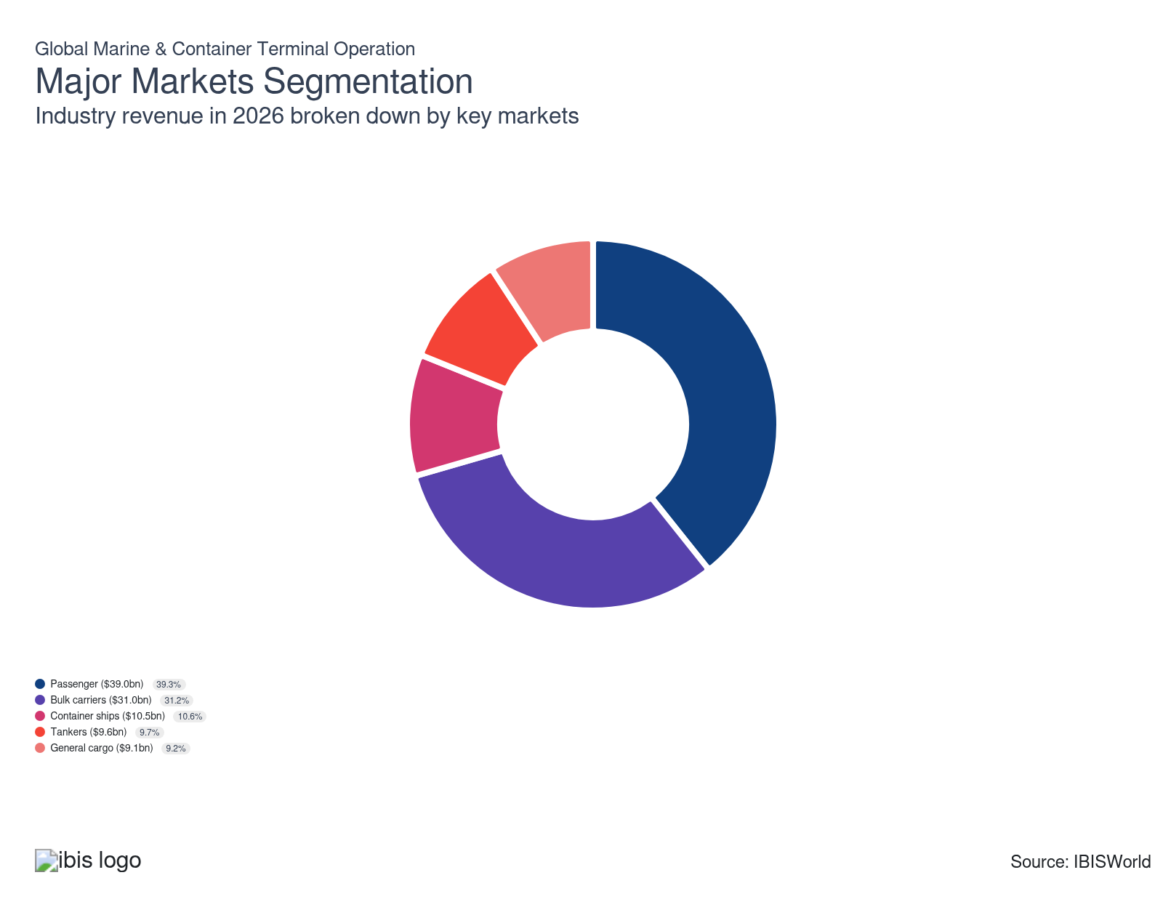

What’s influencing demand from the industry’s markets?

Infrastructure projects and industrial expansion drive general cargo demand
- The general cargo market covers the transport of non-containerized goods, including breakbulk, machinery, steel, timber and project cargo, which require individual handling and customized terminal infrastructure. This segment remains vital because it enables the flow of goods for industries such as construction, agriculture and energy; these are foundational to both mature and emerging economies. As general cargo supports the import and export requirements of goods too large or irregularly shaped for containers, it fills a core operational space that containerized freight can’t match.
- Over the past five years, global demand for general cargo grew alongside large-scale infrastructure investment and rising construction activity, especially in fast-growing markets. Ports serving as key hubs in these activities, like the Port of Virginia, have seen pronounced year-over-year surges in breakbulk volumes (112.1% increase in 2024). Major projects like the Coastal Virginia Offshore Wind development need heavy equipment and over-dimensional cargo handled through specialized means. This isn’t isolated to one region: with growing focus on energy transitions and transport networks worldwide, project cargo flows support general cargo throughput, making this segment continuously relevant to overall port operations and global trade resilience.

Strait of Hormuz disruption weighs on tanker demand
- The tanker market within the industry focuses on transporting liquid cargoes such as crude oil, refined petroleum products and chemicals using specialized vessels. Tankers account for a moderate share of industry revenue, as competition from pipeline infrastructure and increasing use of domestically generated electricity, especially for vehicles, reduces demand for long-haul oil shipping.
- Demand growth has slowed as energy transitions and regional conflict reshape trade routes, with pipeline networks and rising use of domestically generated electricity, including for vehicles, reducing reliance on seaborne oil. Slower global oil trade also reflects the Iran conflict, which has constrained use of the Strait of Hormuz for exports to major buyers like China, where reported crude imports fell to a four-year low in April 2026, alongside weaker LNG arrivals, curbing volume growth at Asian terminals.

Diverging commodity trends reshape bulk carrier demand
- Bulk carriers move unpackaged commodities, such as iron ore, coal and grain, constituting a foundational segment of the marine and container terminal market and demanding specialized port infrastructure for efficient cargo handling. These vessels hold a significant market share, supporting global raw material and agricultural supply chains, particularly for Southeast Asia and Latin America countries experiencing rapid industrial development.
- Demand now splits along regional and policy lines as urbanization and industrial growth in emerging markets lift commodity throughput while decarbonization efforts and energy transitions curb volumes elsewhere. In 2024, the International Energy Agency estimated global coal demand would rise by 1.0%, driven by China and India, while the United States and the European Union recorded year-on-year declines of 12.0% and 5.0%, respectively. China’s focus on boosting domestic coal output and tightening import rules cut seaborne coal shipments 10.0% in 2025, suppressing port activity and bulk volumes.

Ro-Ro and passenger ships anchor steady demand for port operators
- The passenger and Ro-Ro ferry market is a crucial portion of the industry. These vessels bridge vehicle transport and short-distance passenger travel, especially in high-traffic coastal and short-sea corridors. Terminals serving these ships provide infrastructure for ferries, cars or trucks, giving them diverse revenue streams. This segment exceeds what pure freight or passenger-only service ports can offer, delivering more consistent returns by combining both markets in a single business model.
- Several factors drive continued expansion for this segment. Europe's vital trade and tourism links rely on these vessels, especially across the Baltic and Mediterranean. Growing economic integration in Asia has also ramped up demand. Passenger flows are recovering: Eurostat reported 335.3 million passengers boarded ships at EU ports in 2023, nearing the pre-pandemic level. Rapid recoveries in leisure cruise bookings create further passenger flows through these terminals. Altogether, vending diverse marine services boosts overall activity for ports serving these versatile ships, underpinning demand in regions central to global Ro-Ro and short-sea travel markets.

Containerization and trade diversification lift market demand
- The container market is defined by its role in standardizing the movement of uniform shipping containers, streamlining the transport and handling of goods—from perishables to electronics—across global supply chains. This uniformity allows terminals with the required specialized equipment to efficiently process and stow containers. However, operational complexities and physical requirements prevent every port from fully participating, limiting growth and revenue visibility in less-equipped regions.
- Demand for container terminal services rose in 2025 as maritime trade adjusted to geopolitical shocks, redirecting flows toward gateways such as Barcelona and other Spanish ports, South Africa and select Asian hubs that captured rerouted Red Sea traffic and supply chain diversification. Container Trade Statistics reported that, excluding North America, TEU import volumes increased across regions in 2025, with European imports from the Far East surging enough to outweigh headwinds from US tariff measures and other regional tensions.

International Trade

Some industries don't directly import or export goods. See reports at the manufacturing level for international trade data on relevant products.

5. Geographic Breakdown
https://my.ibisworld.com/gl/en/industry/H4913-GL/geographic-breakdown

Key Takeaways
- Asia-Pacific still anchors global terminal volumes and India is now the fastest-growing player. China’s manufacturing base, Singapore’s hub position and India’s double-digit TEU growth are drawing capacity and capital into the region, cementing its role at the center of carrier networks.
- Africa is entering a breakout phase as deep-water concessions reset regional logistics maps. Projects at Lekki, Durban and Tanzanian gateways show how international operators are using PPP concessions to unlock latent demand and shift transshipment away from traditional northern hubs.

Business Locations

Where are industry businesses located?

Asia-Pacific anchors the world's largest terminal volumes through manufacturing proximity and hub geography
- China, Singapore and India collectively account for the highest container throughput volumes of any global region, a distribution rooted in the concentration of industrial production zones across East and South Asia. COSCO's China-origin network processed 28.6 million TEUs in Q1 2026, with the Bohai Rim posting the strongest regional growth at 7.7%, reflecting the enduring pull of China's manufacturing geography on terminal location decisions. Chinese operators have responded to this structural advantage by directing state financing toward 168 ports across 90 countries since 2000, extending geographic reach while consolidating control over port infrastructure serving these industrial zones.
- Singapore's position at the convergence of the east-west and north-south trunk routes makes it the world's primary transshipment hub, handling 44.66 million TEUs in 2025, up 8.6% on the prior year, to claim the top global ranking by throughput volume. Continued growth through the current period of geopolitical disruption confirms that transshipment hubs at geographic choke points capture rerouted cargo rather than lose it. By establishing nine Green and Digital Shipping Corridors, including new corridors with India and South Korea agreed in 2025, Singapore's Maritime and Port Authority has institutionalized this advantage, deepening the regulatory and commercial relationships that keep major carriers committed to the port.
- Among major terminal economies in the Asia-Pacific, India is growing fastest. Jawaharlal Nehru Port Authority handled 7.94 million TEUs in calendar 2025, a 12.64% increase and a historic high, driven by expanding domestic industrial capacity and rising port throughput demand across India's major gateway facilities. APSEZ reinforces this trajectory, becoming the first Indian operator to handle more than 500 million metric tonnes of port cargo in a single financial year. Adani Ports has responded to this structural tailwind by acquiring international terminal concessions, including a 95% stake in Tanzania International Container Terminal Services through its joint venture with AD Ports Group, as part of a broader global expansion.

West and East Africa recording the fastest throughput growth of any region
- Deep-water terminal investment is driving Africa into a new phase of accelerated throughput growth. Nigeria's total port throughput rose 24.8% in 2025, making it among the fastest-growing port markets globally, with transshipment volumes the primary engine. Containers transshipped through Nigerian ports jumped 205.8%, confirming that shipping lines are rerouting West and Central African relay cargo that previously transited northern hemisphere hubs such as Algeciras or Tanger Med. Lekki Deep Sea Port has repositioned Nigeria as a West African transshipment hub, capturing a dominant share of national container traffic as volumes more than doubled from a greenfield base.
- South Africa's Durban is undergoing a structural transformation under a 25-year public-private partnership that began on January 1, 2026. ICTSI's operation of Durban Container Terminal Pier 2 targets a material increase in capacity, alongside a productivity improvement from 18 to 28 gross crane moves per hour. Q1 2026 consolidated throughput across ICTSI's global portfolio rose 18% year-on-year, with the Durban Gateway Terminal identified as a primary growth driver. Established through transparent international competitive procurement, the Transnet partnership structure establishes a concession model that South Africa's port sector industry body, SAAFF, is advocating for extension across additional port facilities, with independent tariff oversight.
- The pace of African port investment reflects a broader recognition by global terminal operators that sub-Saharan Africa's port infrastructure deficit is a commercial opportunity. AD Ports Group and Adani's acquisition of a 95% stake in Tanzania International Container Terminal Services confirms the pattern visible at Lekki and Durban, where internationally capitalized operators are entering African markets through concession structures rather than greenfield development, accelerating capacity deployment while limiting sovereign risk exposure. State-owned port authorities that resist private concession structures face a growing productivity and investment gap as international operators raise the operational benchmarks that shipping lines use to allocate vessel calls.

US East and Gulf Coast ports are gaining share as West Coast terminals absorb trade policy disruption
- US container terminal activity is bifurcating geographically. West Coast major ports at Los Angeles, Long Beach, and Seattle/Tacoma posted year-on-year volume declines ranging from 11% to 14% in January 2026, driven by a base-effect comparison against the 2025 tariff-surge pull-forward as terminal operators processed a concentrated burst of pre-announcement cargo. These declines reflect a structural shift in US sourcing geography that has begun to compress berth utilisation at West Coast facilities, with vessel call frequency on the trans-Pacific lane falling materially.
- East and Gulf Coast facilities are capturing the cargo that West Coast ports are losing. Georgia Ports Authority grew 9.1% in January 2026 and Port Houston recorded its highest-ever January throughput, as carriers aligned to Atlantic and Gulf routes from diversified Asian origins benefited from the structural rerouting (Gravity Concepts, 2026). This geographic shift is structural rather than cyclical: carriers designating East and Gulf hubs under the Gemini hub-and-spoke model (Maersk and Hapag-Lloyd, launched February 2025) are committing multi-year volume guarantees that lock in route economics for the medium term. Committed to serving this sustained rerouting, the Port Authority of New York and New Jersey approved a capital programme from 2026 to 2035 that includes port infrastructure components alongside broader transportation investment.
- Latin America is emerging as a distinct growth zone driven by nearshoring and vessel network redesign. DP World's Lima terminal at Callao surpassed 2 million TEUs for the first time in 2025, making it the first South American west coast terminal to reach that threshold, while Dominican Republic's Caucedo terminal recorded 1.76 million TEUs driven by nearshoring-related cargo (DP World, 2026). COSCO's Chancay mega-port in Peru more than doubled throughput volumes in 2025 as it ramped to full operations. Terminals on Pacific-facing Latin American routes serve nearshoring-driven cargo more efficiently than West Coast gateways, as carrier network redesign and vessel upsizing concentrate incremental volumes at strategically positioned gateways with lower inland drayage costs.
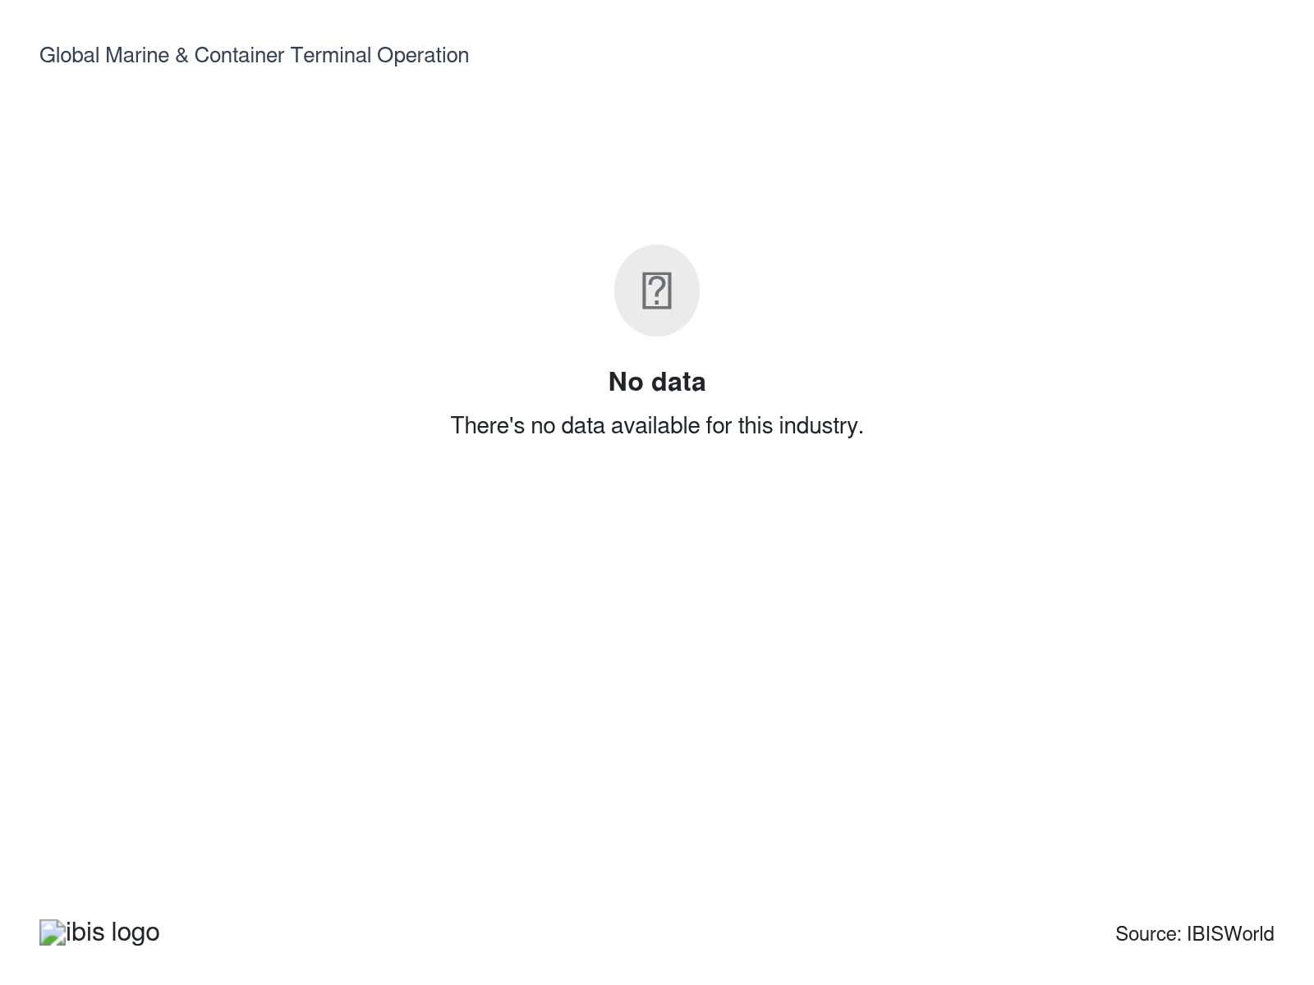

How do businesses use location to their advantage?
Ensure easy access to further appropriate land for development
Large tracts of waterfront land close to cities or industrial operations are hard to acquire because much of the land is taken. With global marine transport continuing to grow, many operators will likely need to develop new space to service customers.
Ensure proper licensing
To set up an establishment, operators need to obtain the proper licenses to start building a port. Ports take up a large plot of land and need to be approved by the proper authorities.

6. Competitive Forces
https://my.ibisworld.com/gl/en/industry/H4913-GL/competitive-forces

Key Takeaways
- Megadeals are trying to knit together a more concentrated landscape, but geopolitics keeps getting in the way. The BlackRock–GIP–TiL bid for Hutchison’s ports has run into Chinese reviews, cancelled concessions and expiring exclusivity, while a COSCO-led outcome would reshape ownership along very different lines.
- The capital and time needed for a new terminal are beyond most newcomers. Greenfield projects can cost billions and take many years to complete, sharply limiting the number of businesses able to enter without substantial upfront investment.

Concentration
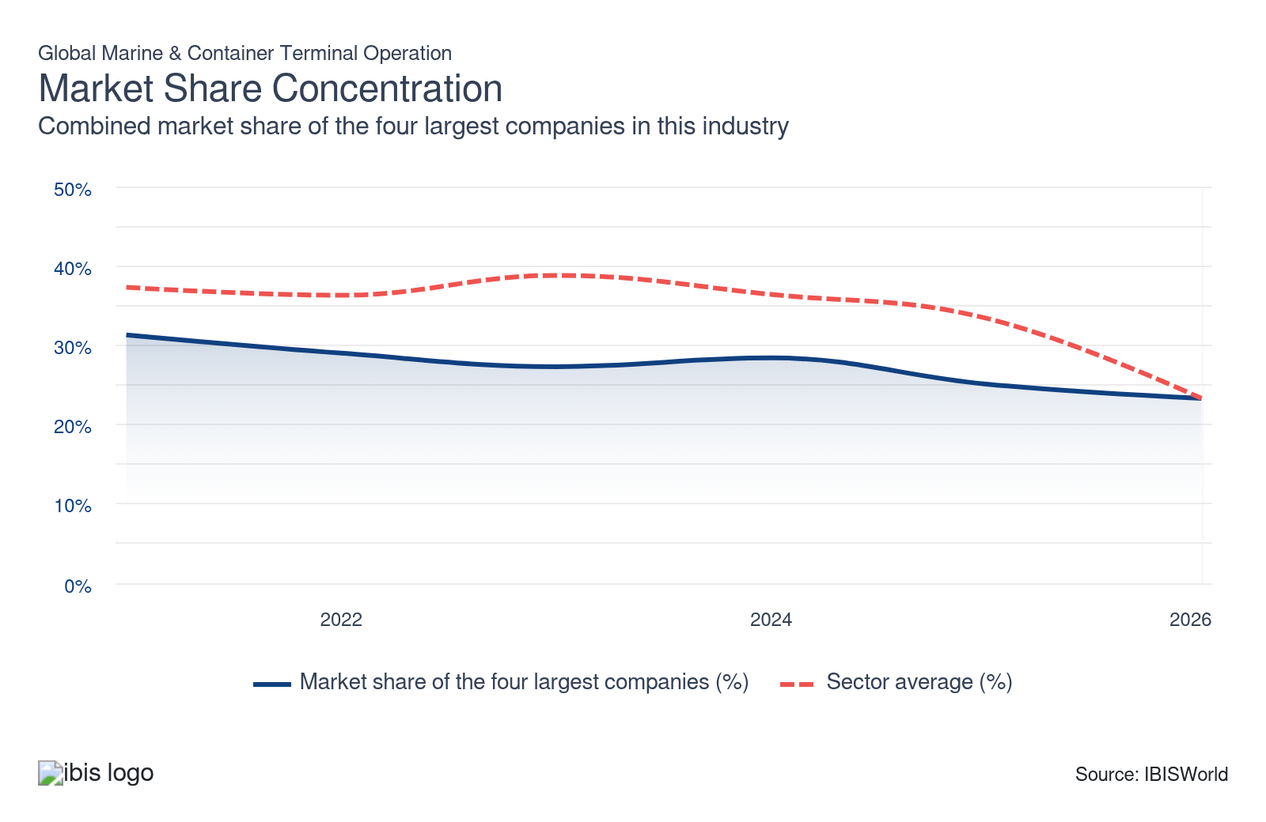

What impacts the industry’s market share concentration?

Different regions have vastly different levels of concentration
- Geographic segmentation shapes market share in the industry. While the US is a large maritime market, traffic and value are unevenly distributed. For example, Bureau of Transportation data for 2022 shows the Houston Port Authority leads in overall tonnage thanks to its capacity. Still, Louisiana’s South Louisiana port outperforms it in dry bulk because of regional commodity specialization.
- Terminal businesses seeking to maximize returns face opportunity costs, as focusing on hubs with high total throughput doesn’t always capture specialized market value. Commodity flows, such as dry bulk versus fuels, tend to cluster in regions suited for those needs, preventing any single operator from dominating broadly. This fragmented landscape limits industry concentration.

Landmark M&A is attempting to reverse fragmentation, but geopolitical complexity threatens deal structures
- The largest consolidation attempt in at least two decades centres on the BlackRock-GIP-Terminal Investment Limited (TiL) consortium's $22.8 billion agreement to acquire CK Hutchison's 90% stake in Hutchison Port Holdings' international portfolio. A completed deal as originally structured would vault TiL (MSC-affiliated) to the forefront, fundamentally restructuring the Top-4 composition and reversing the fragmentation trend visible in IBISWorld's 2026 data.
- The original deal structure has since collapsed under geopolitical pressure. China launched an antitrust and national security review; Panama annulled existing Hutchison concessions on 24 February 2026 and handed interim operations to Maersk and MSC; COSCO demanded majority ownership of any divested Chinese-market assets; and BlackRock-TiL's exclusivity period has expired. As of May 2026, CK Hutchison is in direct negotiations with a major Chinese strategic investor widely understood to be COSCO, making the final ownership structure uncertain.
- The second major consolidation event - Hapag-Lloyd's acquisition of ZIM Integrated Shipping Services at a substantial premium - is advancing toward an expected close in late 2026. Per gCaptain (2026), the combined entity would carry approximately 9.2% of global container carrier market share, with estimated annual synergies of $300 to $500 million. Carrier consolidation at this scale feeds terminal concentration by giving integrated carrier-operators a larger proprietary cargo base to anchor dedicated terminal volumes.

Major capital investments by large businesses limits market share concentration
- High and increasing barriers to entry structurally limit the fragmentation of market share below the existing operator tier. At 9.4% of revenue, the industry's depreciation burden is more than triple the broader sector benchmark of 3.0%, reflecting the infrastructure scale required to compete - berths, cranes, container handling equipment, and yard management systems. A new greenfield terminal such as the Rijeka Gateway project in Croatia carries a total investment exceeding €600 million.
- Automation investment is widening the productivity gap between established operators and potential entrants. According to the Greater Houston Port Bureau (2026), terminals with full automation report labor cost reductions of 25-55% relative to pre-automation baselines, a per-unit throughput advantage that new entrants cannot replicate without matching capital commitments. Greenfield capital continues to flow through incumbent channels, with PSA Singapore's Tuas Phase 2 automation expansion launching in early 2026 and the Hanseatic Global Terminals joint venture (Hapag-Lloyd-affiliated) developing a new terminal in Aracruz, Brazil.
- Twenty- to fifty-year concession agreements granted by national governments or port authorities cement incumbent market positions independent of competitive performance. These long-dated agreements structurally anchor concentration at its current level by making incumbent displacement dependent on state intervention rather than competitive dynamics.

How do successful businesses handle concentration?
Ability to comply with environmental legislation
State and national governments impose differing levels of environmental regulation, ranging from largely unregulated frameworks in more recently industrialized countries to increasingly prescriptive rules in places like Europe and the United States. Recognizing and handling this discrepancy with agility is a must for operators in a global industry.
Ability to accommodate fluctuations in demand
Cargo loads can fluctuate considerably based on seasonal, economic or weather conditions. Adjusting throughput capacity and staffing levels in response to these patterns increases efficiency and competitiveness.

Barriers to Entry
High | Increasing

What challenges do potential industry entrants face?

Legal
- Terminal operators must secure port concession agreements from national governments or port authorities, with contract terms typically spanning 20 to 50 years. These concessions are increasingly treated as strategic state assets, raising the threshold for non-aligned entrants.

Start-up Costs
- Greenfield terminal development requires hundreds of millions to billions of dollars in upfront capital, with IBISWorld data confirming the industry's exceptional capital intensity: depreciation accounts for 9.4% of revenue, more than three times the sector average. Compounding the investment requirement, construction and permitting timelines typically run five to ten years from planning to operations, extending the payback horizon well beyond what most new entrants can absorb.

Differentiation
- Marine terminals compete on location and waterfront real estate adjacent to deep-water channels is geographically fixed and largely controlled by established operators through long-term concession agreements. Carrier alliance restructuring has intensified this barrier, with the Gemini Cooperation (Maersk and Hapag-Lloyd) concentrating vessel calls at hub ports in Rotterdam and Singapore, leaving non-hub terminals to compete for residual volumes.

Capital Expenses
- Automation is widening the cost gap between incumbent operators and potential entrants. According to the Greater Houston Port Bureau (2026), full terminal automation reduces labor costs per unit throughput by 25.0% to 55.0%, but realizing those savings requires substantial capital outlay.

How can potential entrants overcome barriers to entry?
Accommodate environmental requirements
State and national governments impose differing levels of environmental regulation, ranging from largely unregulated frameworks in newly industrialized countries to increasingly prescriptive rules in Europe and the United States.
Ensure proper licensing
To set up an establishment, operators need to obtain the proper licenses to start building a port. Terminals take up a large plot of land and need to be approved by the proper authorities.

Substitutes
Low | Steady

What are substitutes for industry services?

No Substitutes
- Marine cargo terminal services face no viable substitute for intercontinental bulk and containerized freight at scale. Rated Very Low with a Steady trend by IBISWorld, the availability of substitutes is the lowest competitive force in the industry's structure. No competing transport mode can match ocean shipping's cost-per-tonne economics for large-volume, long-distance cargo movements.
- Road and rail networks cannot replace marine routes, functioning instead as downstream distributors that move cargo from port to final destination. Given their capacity and infrastructure limits, these modes cannot replicate intercontinental marine routes. Air freight handles only high-value, low-volume cargo and cannot economically carry bulk commodities, assembled vehicles, consumer goods, or energy products at the volumes served by ocean vessels.

How do successful businesses compete with substitutes?
Invest in new technology to enhance operational efficiency and quality
Marine and container terminal operators rely on the newest technology to streamline operations, cut costs and improve service quality. Adopting technologies like automation, AI and IoT can help operators fulfill rapid delivery requirements and avoid losing business to faster cargo airlines.
Produce a differentiated product
Container terminals located away from other major ports can offer a new method of cost-effective transport to shippers looking to avoid lengthy land transport or costly air transport.

Buyer & Supplier Power
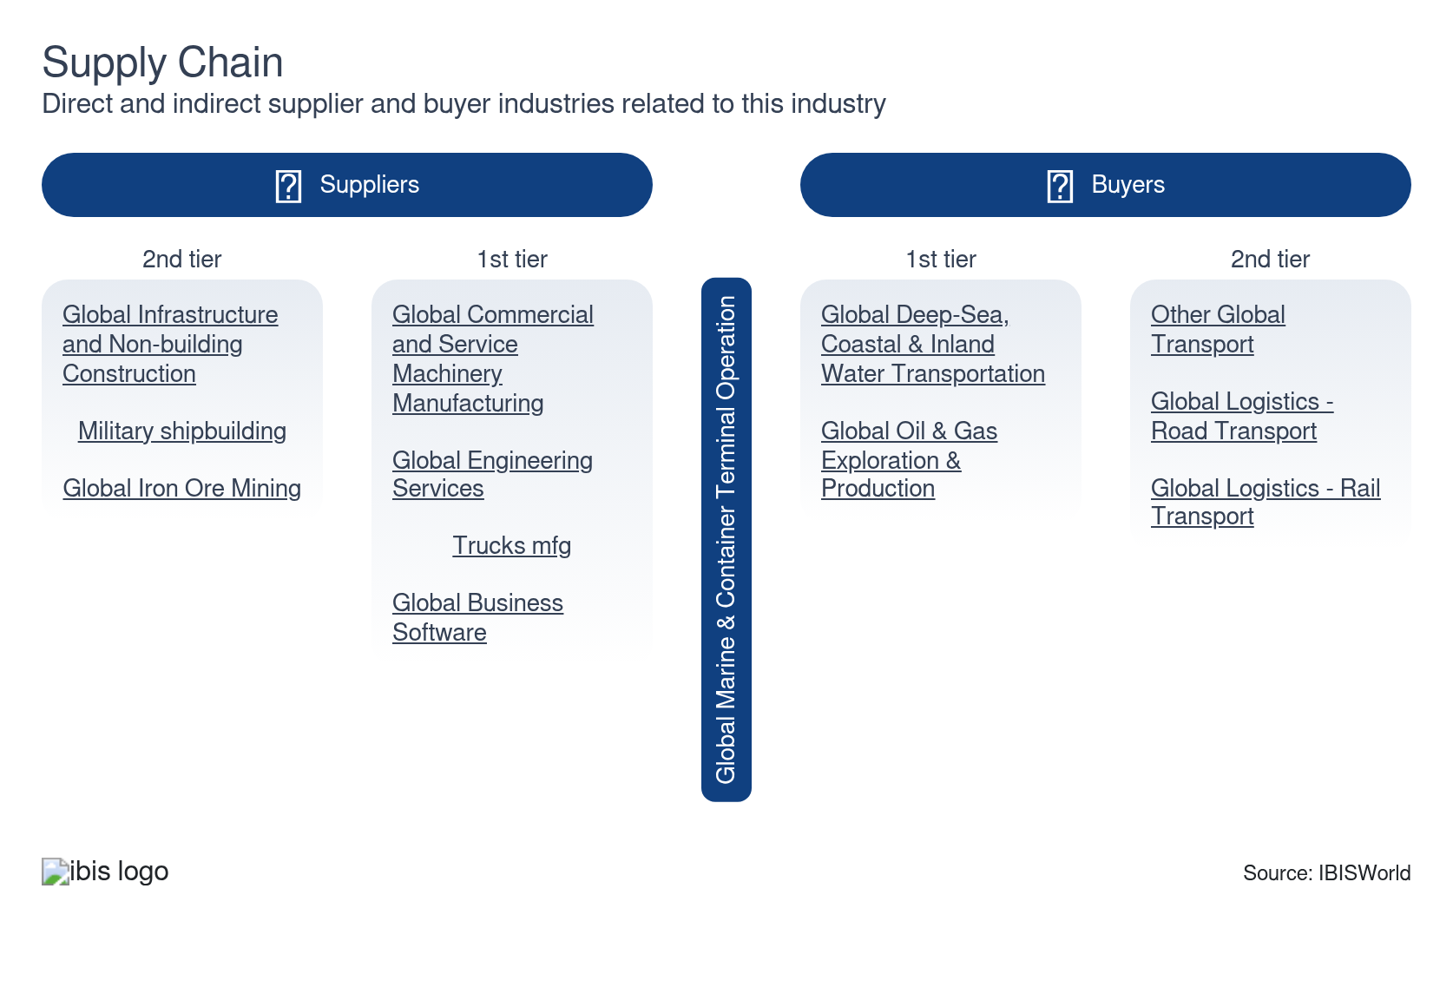

What power do buyers and suppliers have over the industry?

Buyers: Operating capacity
Low | Steady
- Buyers include any industry that needs products from overseas or the shipping company itself. These clients rely on terminal operators to load and unload cargo and prepare all necessary paperwork to declare its import or export.
- Marine and container terminal operators' demand is beholden to their clients' production capacities. When global consumer spending is high, manufacturers ship more products through the industry's facilities.
- Shipping companies and manufacturers have very little access to alternatives and aren't able to influence the industry's prices. Terminals in prime locations make shipping cheaper and can charge higher prices.

Suppliers: Depreciation costs
Moderate | Steady
- Marine and container terminals use an array of heavy machinery to load and unload cargo. Cranes and other equipment depreciate, forcing operators to regularly purchase new parts or entirely new units from suppliers. Over a fifth of the industry's revenue goes to depreciation expenses.
- Fuel costs also impact the industry's operating costs. These expenses have been exceptionally volatile amid COVID-19 and the Russia-Ukraine war.

How do successful businesses manage buyer & supplier power?
Develop an extensive distribution network
Marine and container terminal operators need a broad distribution network to ensure reliable and efficient operations across various geographies, reducing reliance on single suppliers or markets. A broader distribution network gives clients more reach, reducing their influence over prices.
Secure economies of scale
Marine and container operators with larger capacities can better weather the effects of depreciation and volatile fuel costs.

7. Companies
https://my.ibisworld.com/gl/en/industry/H4913-GL/companies

Key Takeaways
- All major operators are growing revenue while losing market share to faster-expanding mid-tier competitors. DP World, PSA, CK Hutchison, and Maersk together hold around 30.0%. The BlackRock-TiL/Hutchison deal, stalled in regulatory review, is large enough to reshape that ranking.
- Challenger operators like APSEZ and ICTSI are reshaping the competitive tier below the global leaders. Both captured throughput surges by securing concessions in underserved geographies ahead of incumbents. They're capturing the volume disruption is pushing outside established hubs.

Market Share
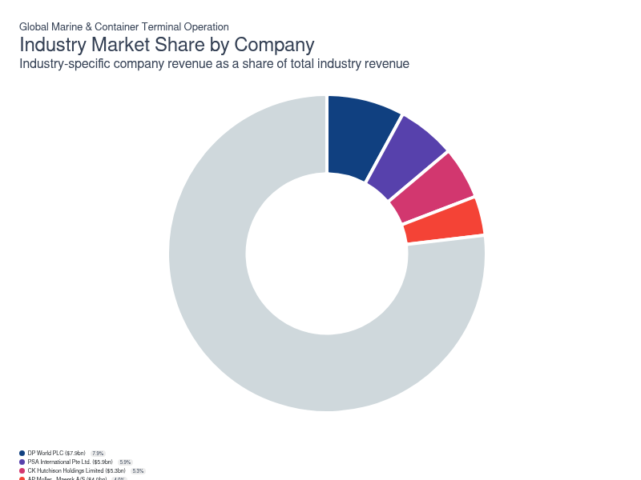
Chart displays current year only in the PDF version of this report. You can view and download chart for all other years associated with this industry on my.ibisworld.com.

Companies
Company | Market Share (%)  2026 | Revenue ($m)  2026 | Profit ($m)  2026 | Profit Margin (%)  2026
DP World PLC | 7.9 | 7,872.4 | 2,100.1 | 26.7
PSA International Pte Ltd. | 5.9 | 5,889.6 | 890.8 | 15.1
CK Hutchison Holdings Limited | 5.3 | 5,294.4 | 542.7 | 10.3
AP Moller - Maersk A/S | 4.0 | 4,017.1 | 151.2 | 3.8

DP World PLC
DP World PLC
Company Details
Company Details
Industry Specific Revenue (2026) | $7.9bn
Industry Profit (2026) | $2.1bn
Market Share (2026) | 7.9%

Description
Description
Dubai-based DP World is a marine terminal operations and development company owned by the government of Dubai in the United Arab Emirates. The company began operating in 1972 by developing and managing Port Rashid. The company in its current form was founded in 2005, with CSX World Terminals LLC and Peninsular and Oriental Steam Navigation Company being acquired in 2005 and 2006, respectively. In 2021, the company employed about 71,000 people across 69 countries (latest data available).

Company’s Industry Revenue, Market Share, and Profit Margin Over Time
Company’s Industry Revenue, Market Share, and Profit Margin Over Time
Year | Industry Revenue ($ million) | Market Share (%) | Profit Margin (%)
2018 | 4296 | 8.1 | 15.2
2019 | 4069 | 7.7 | 13.9
2020 | 4501 | 9.2 | 38.9
2021 | 5543 | 8.6 | 35.5
2022 | 6058 | 7.6 | 29.3
2023 | 6399 | 7.7 | 28.0
2024 | 7725 | 8.7 | 27.2
2025 | 7872 | 8.6 | 26.7
2026 | 7872 | 7.9 | 26.7

What's impacting DP World PLC's performance?

Acquisitions lead to company expansion
- In 2017 and 2018, DP World invested to expand its operations and 20.0-foot equivalent units capacity in Prince Rupert, Canada; Posorja, Ecuador; Jebel Ali, UAE; London Gateway, UK; and Berbera, Somaliland.
- In 2019, the company continued its acquisition initiative, with Topaz Energy and Marine Limited and P&O Ferries being the two largest purchases. Through these acquisitions, the company boosted its drydocking, maritime and logistics services by merging both businesses with its existing P&O Maritime Services business to form P&O Maritime Logistics (POML).
- In July 2021, the company acquired Syncreon and Imperial Logistics. Syncreon is a US-based company with strong logistics solutions capability across 91 sites in 19 countries. Imperial Logistics is an integrated logistics company with a presence across Europe and Africa.

Commitment toward carbon reduction
- The company is committed to being a net-zero carbon enterprise by 2040. The company's port business in Rotterdam has already achieved net-zero operational status in 2021.
- The company launched priority decarbonization programs in line with the Science Based Targets initiative (SBTi).
- DP World has continued its equipment electrification program at three different sites. In addition, the company entered a strategic partnership with Maersk Mc-Kinney Moller Center for Zero Carbon Shipping.
PSA International Pte Ltd.
PSA International Pte Ltd.
Company Details
Company Details
Industry Specific Revenue (2026) | $5.9bn
Industry Profit (2026) | $890.8m
Market Share (2026) | 5.9%

Description
Description
Singapore-based PSA is one of the world's largest port and terminal operators The company is owned by Temasek Holdings Private Limited, Singapore's sovereign wealth fund. Originally named the Port of Singapore Authority, the company was established in 1964 to regulate, develop, operate and promote the Port of Singapore's terminals. Currently, the company employs more than 13,000 workers and handles a container throughput of 91.5 million 20.0-foot equivalent units (TEUs) in 2021 (latest data available).

Company’s Industry Revenue, Market Share, and Profit Margin Over Time
Company’s Industry Revenue, Market Share, and Profit Margin Over Time
Year | Industry Revenue ($ million) | Market Share (%) | Profit Margin (%)
2018 | 2739 | 5.1 | 31.2
2019 | 2711 | 5.1 | 29.7
2020 | 3030 | 6.2 | 28.3
2021 | 3475 | 5.4 | 25.4
2022 | 5798 | 7.3 | 17.7
2023 | 5283 | 6.3 | 17.4
2024 | 5779 | 6.5 | 15.4
2025 | 5890 | 6.4 | 15.1
2026 | 5890 | 5.9 | 15.1

What's impacting PSA International Pte Ltd.'s performance?

Red Sea attacks impact global shipping, boosting PSA International's Singapore port expansion plans
- The ongoing attacks in the Red Sea have diverted maritime traffic toward Asia, significantly increasing container throughput at the port of Singapore. In 2024, the Maritime and Port Authority of Singapore reported handling 41.1 million containers, reflecting heightened demand for the city-state’s logistics infrastructure.
- The company plans to add more berths at Tuas Port in response to this surge. This expansion aims to accommodate increased business activity, attract further investment and strengthen its position in the global shipping sector. Enhanced capacity could improve revenue streams and competitiveness as shipping routes and trade dynamics evolve.

PSA's evolving technologies can be attributed to growth
- The Global Terminal Operating System (GTOS) provides an integrated solution that empowers end-to-end terminal operations around the clock. It's continuously enhanced to adapt to an evolving world where terminals are able to respond better to supply chain disruptions, similar to COVID-19.
- Global Portnet (GPN) aims to simplify complex and integrative networks of information. GPN orchestrates efficient workflows between the port and its adjacent community, shipping lines, government agencies and maritime service providers, reducing turnaround time, delivering higher value and enhancing inter-operability among port users.
CK Hutchison Holdings Limited
CK Hutchison Holdings Limited
Company Details
Company Details
Industry Specific Revenue (2026) | $5.3bn
Industry Profit (2026) | $542.7m
Market Share (2026) | 5.3%

Description
Description
Hong Kong-based CK Hutchison was formed in 2015 through the merger and restructuring of Cheung Kong Limited and Hutchison Whampoa Limited. CK Hutchison operates in more than 50 countries and employs more than 300,000 workers.

Company’s Industry Revenue, Market Share, and Profit Margin Over Time
Company’s Industry Revenue, Market Share, and Profit Margin Over Time
Year | Industry Revenue ($ million) | Market Share (%) | Profit Margin (%)
2018 | 4488 | 8.4 | 16.1
2019 | 4515 | 8.5 | 16.2
2020 | 4237 | 8.6 | 24.0
2021 | 5440 | 8.4 | 25.0
2022 | 5637 | 7.1 | 26.0
2023 | 5218 | 6.2 | 22.7
2024 | 5803 | 6.6 | 21.5
2025 | 5294 | 5.8 | 10.3
2026 | 5294 | 5.3 | 10.3

What's impacting CK Hutchison Holdings Limited's performance?

Company structure remains intact
- CK Hutchison's industry-relevant operations, primarily run via Hutchison Port, are accounted for in its ports and related services division, which includes an 80.0% stake in Hutchison Port and a 30.0% interest in HPH Trust.
- Collectively, these operations handled a container throughput of 88.0 million 20.0-foot equivalent units in 2021 (latest data available). The division holds interest in 52 ports, including six of the world's 10 busiest ports and 291 operational berths in 27 countries.

CK Hutchison Receives SBTi Approval and Reports Drop in Carbon Intensity
- CK Hutchison received approval from the Science Based Targets Initiative (SBTi) in 2023 to implement a sustainability plan that targets a 54.6% reduction in Scope 1 and Scope 2 emissions by 2033, primarily through increased operations electrification. The SBTi provides a framework for companies to align greenhouse gas reductions with climate science.
- In 2024, the company reported a year-over-year decrease in carbon intensity of 5.0%, reflecting measurable progress in reducing its emissions portfolio. These efforts may enhance CK Hutchison’s reputation among service buyers and position the company to better comply with potential future regulations on port operations sustainability, potentially supporting both business growth and regulatory compliance.
AP Moller - Maersk A/S
AP Moller - Maersk A/S
Company Details
Company Details
Industry Specific Revenue (2026) | $4.0bn
Industry Profit (2026) | $151.2m
Market Share (2026) | 4.0%

Description
Description
Established in 1904 and headquartered in Copenhagen, AP Moller - Maersk A/S (Maersk) is one of the largest maritime shipping companies in the world. Maersk is also involved in various activities within the energy, marine terminal operation and trucking industries. The company's main divisions are Maersk Line and APM Terminals. Maersk participates in the Global Deep-Sea, Coastal and Inland Water Transportation industry through the Maersk Line business, which employs more than 80,000 people worldwide.

Other Industries
Other Industries
- GLGlobal DeepSea, Coastal & Inland Water Transportation

Company’s Industry Revenue, Market Share, and Profit Margin Over Time
Company’s Industry Revenue, Market Share, and Profit Margin Over Time
Year | Industry Revenue ($ million) | Market Share (%) | Profit Margin (%)
2020 | 3151 | 6.4 | 8.3
2021 | 4000 | 6.2 | 30.3
2022 | 4371 | 5.5 | 37.1
2023 | 3844 | 4.6 | 8.5
2024 | 4465 | 5.0 | 12.3
2025 | 4017 | 4.4 | 3.8
2026 | 4017 | 4.0 | 3.8

You can view and download company details on my.ibisworld.com.

8. External Environment
https://my.ibisworld.com/gl/en/industry/H4913-GL/external-environment

Key Takeaways
- Mediterranean and Arctic ECAs are pushing new compliance costs onto ports. Operators in places like Marseille and Piraeus now have to test fuels and police scrubber discharges, adding recurring overhead that lands squarely on port and harbor operations.
- EU, Indian and Singaporean programs are lowering the cost of port decarbonization and expansion. By subsidizing shore power, alternative fuels and big-ticket modernization, they let terminal operators upgrade faster without shouldering the full capital burden.

External Drivers

What demographic and macroeconomic factors impact the industry?
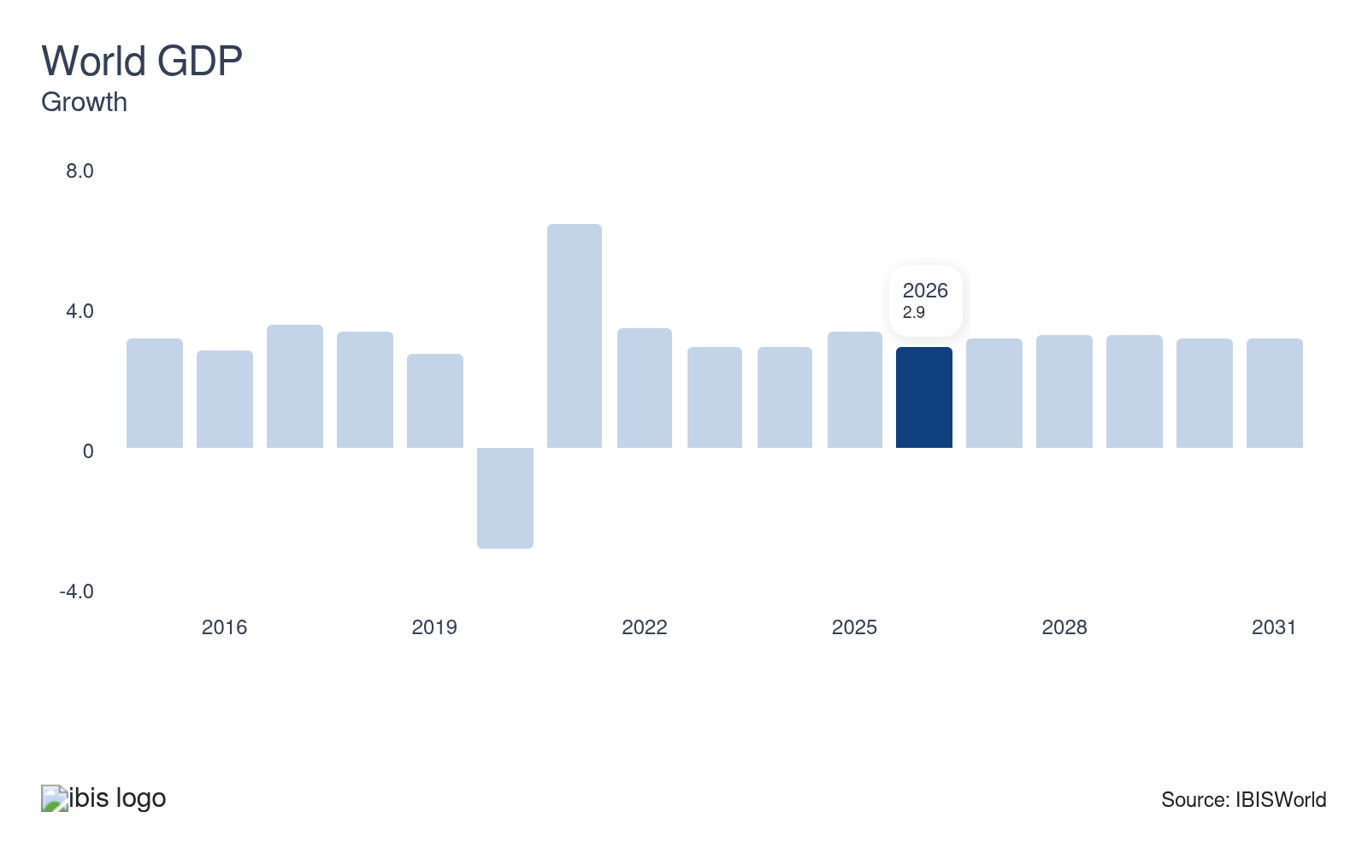
World GDP measures the aggregate output of the global economy. Sustained economic expansion raises industrial activity, household incomes, and cross-border trade volumes simultaneously, increasing the overall cargo throughput that marine terminals must process. Because terminal revenue scales with handling fees and vessel calls, even modest acceleration in global output translates directly into higher terminal utilisation and handling-fee income.
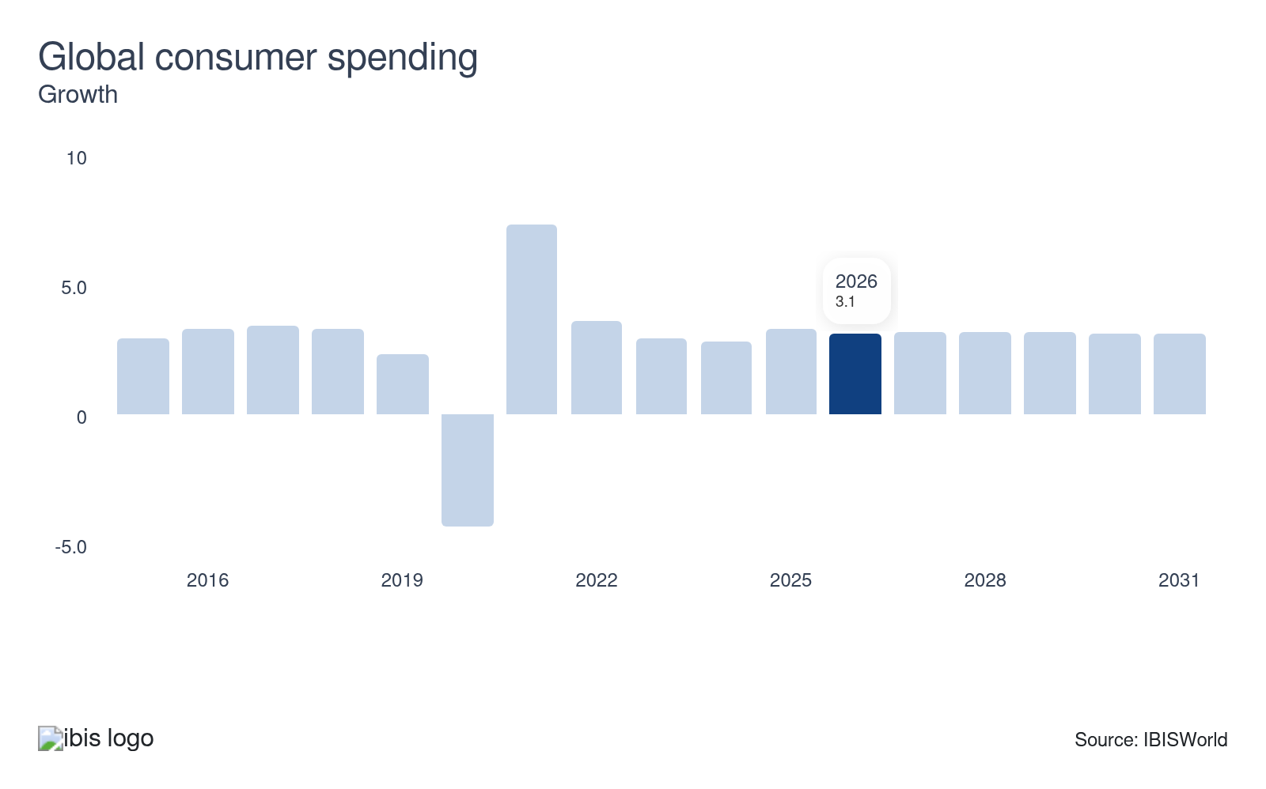
Consumer spending across major economies reflects households' aggregate demand for commercially traded goods. When spending rises, demand for manufactured and retail products transported along ocean routes increases, pulling additional cargo volumes through marine and container terminals. The sensitivity is highest for electronics, apparel, and fast-moving consumer goods, which generate dense containerised cargo streams that lift throughput volumes and handling-fee revenues at container-focused terminals.
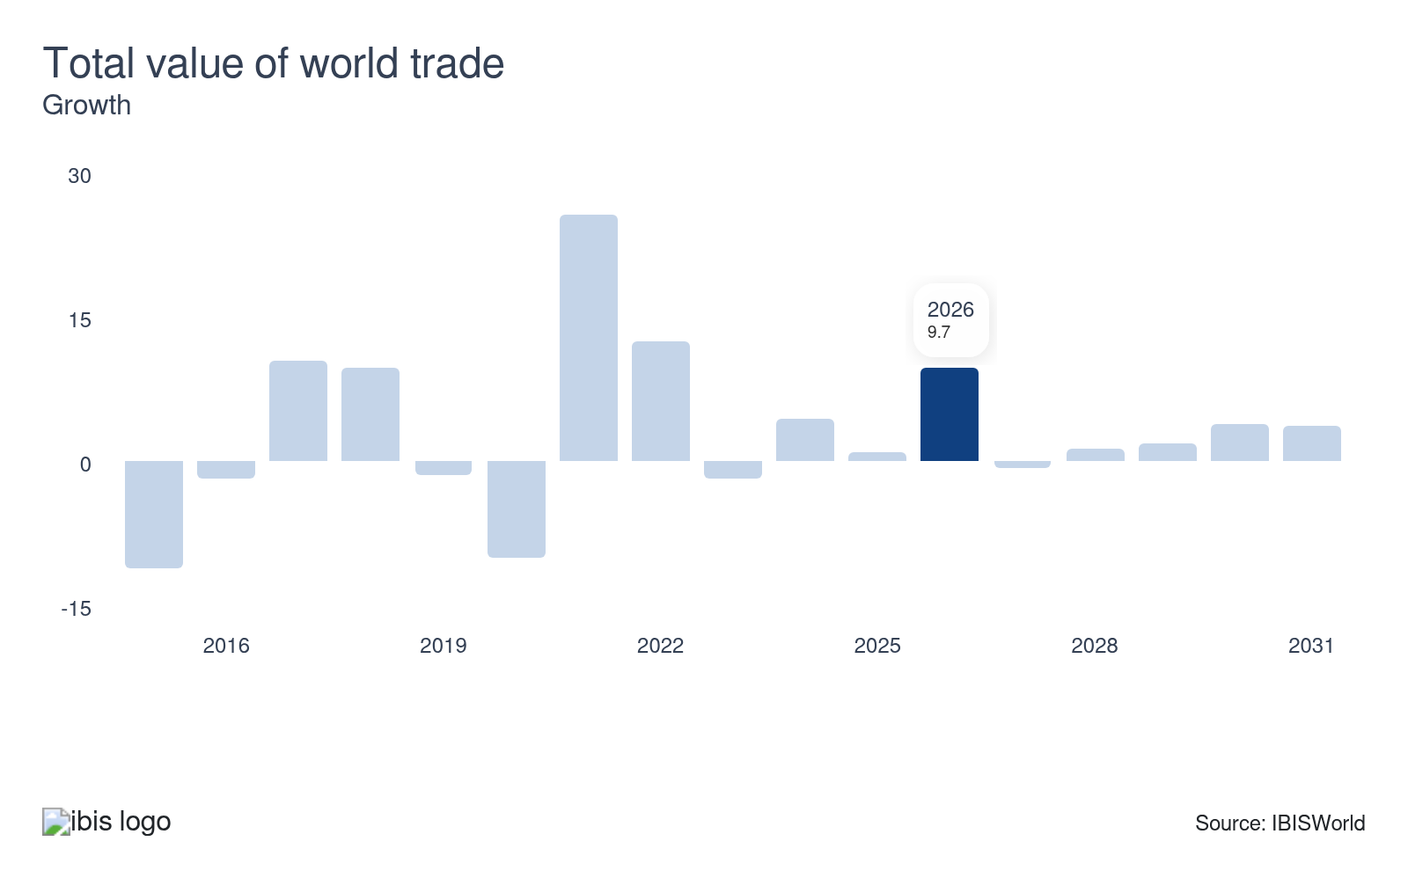
The total value of world trade measures the aggregate worth of goods and services crossing international borders. Ships carry the vast majority of global trade by volume, so any sustained expansion directly lifts cargo throughput at marine terminals, generating higher handling volumes and surcharge revenues. For terminal operators, rising trade values represent an opportunity, as utilization and pricing power move in step with the driver.
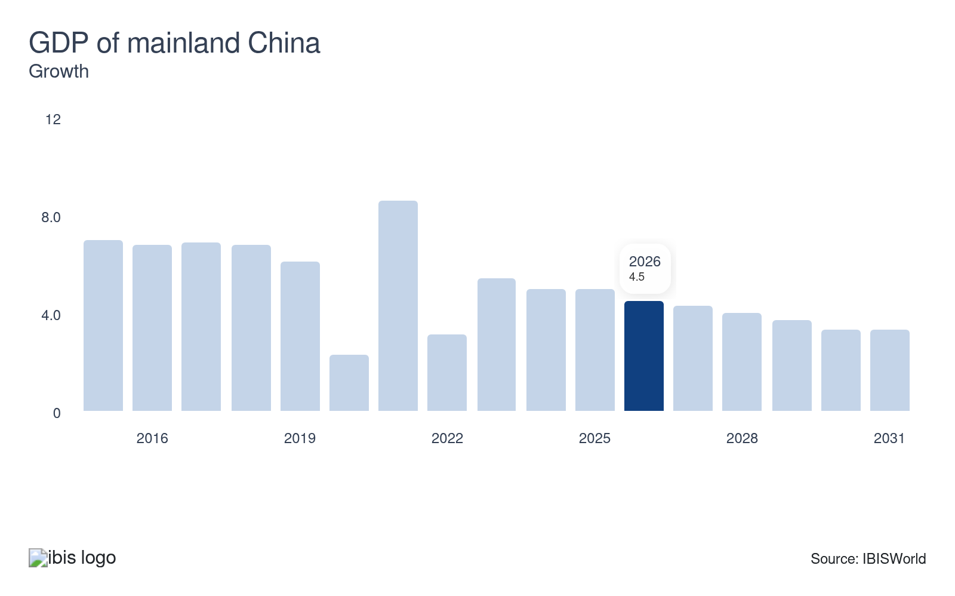
China's GDP growth directly influences the volume of manufactured goods moving through global shipping networks, given China's position as the world's leading exporter of industrial and consumer products. When China's economy expands, export volumes rise, increasing calls at origin terminals in Chinese ports and at destination terminals handling Chinese-origin cargo. Slowdowns in China's GDP growth produce the reverse effect, reducing container shipping demand across key trade lanes.
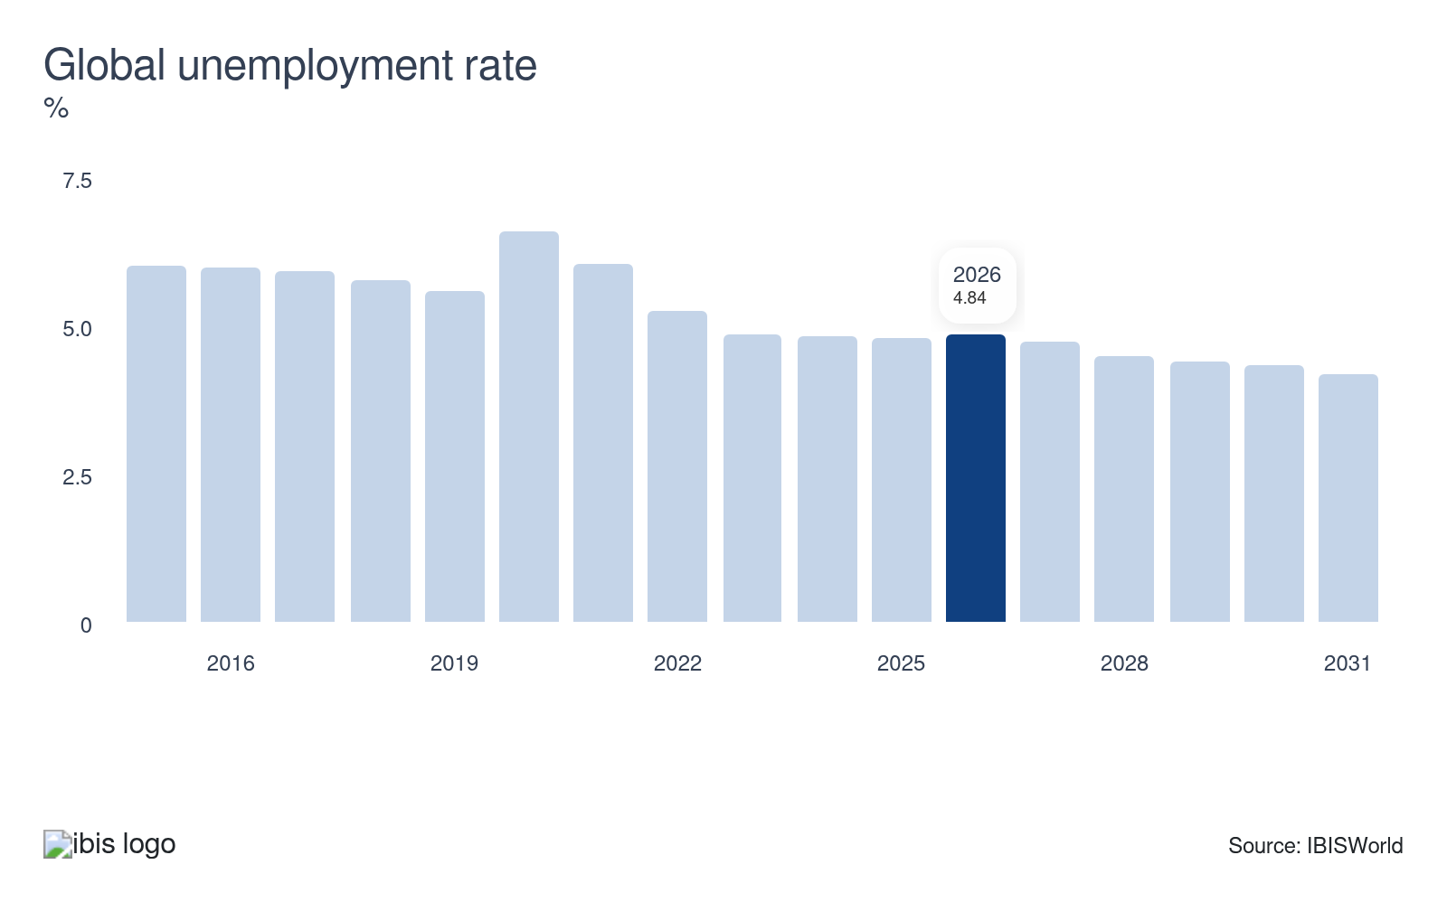
Global unemployment captures the share of the labor force without work across major economies. Rising unemployment reduces household incomes, contracting consumer spending on traded goods and the manufacturing activity that generates cargo. Because terminal revenue depends on cargo throughput and vessel calls, higher global unemployment dampens both trade volumes and handling fee revenue. Rising global unemployment represents a threat to terminal operators because cargo demand weakens as joblessness spreads and household spending contracts.
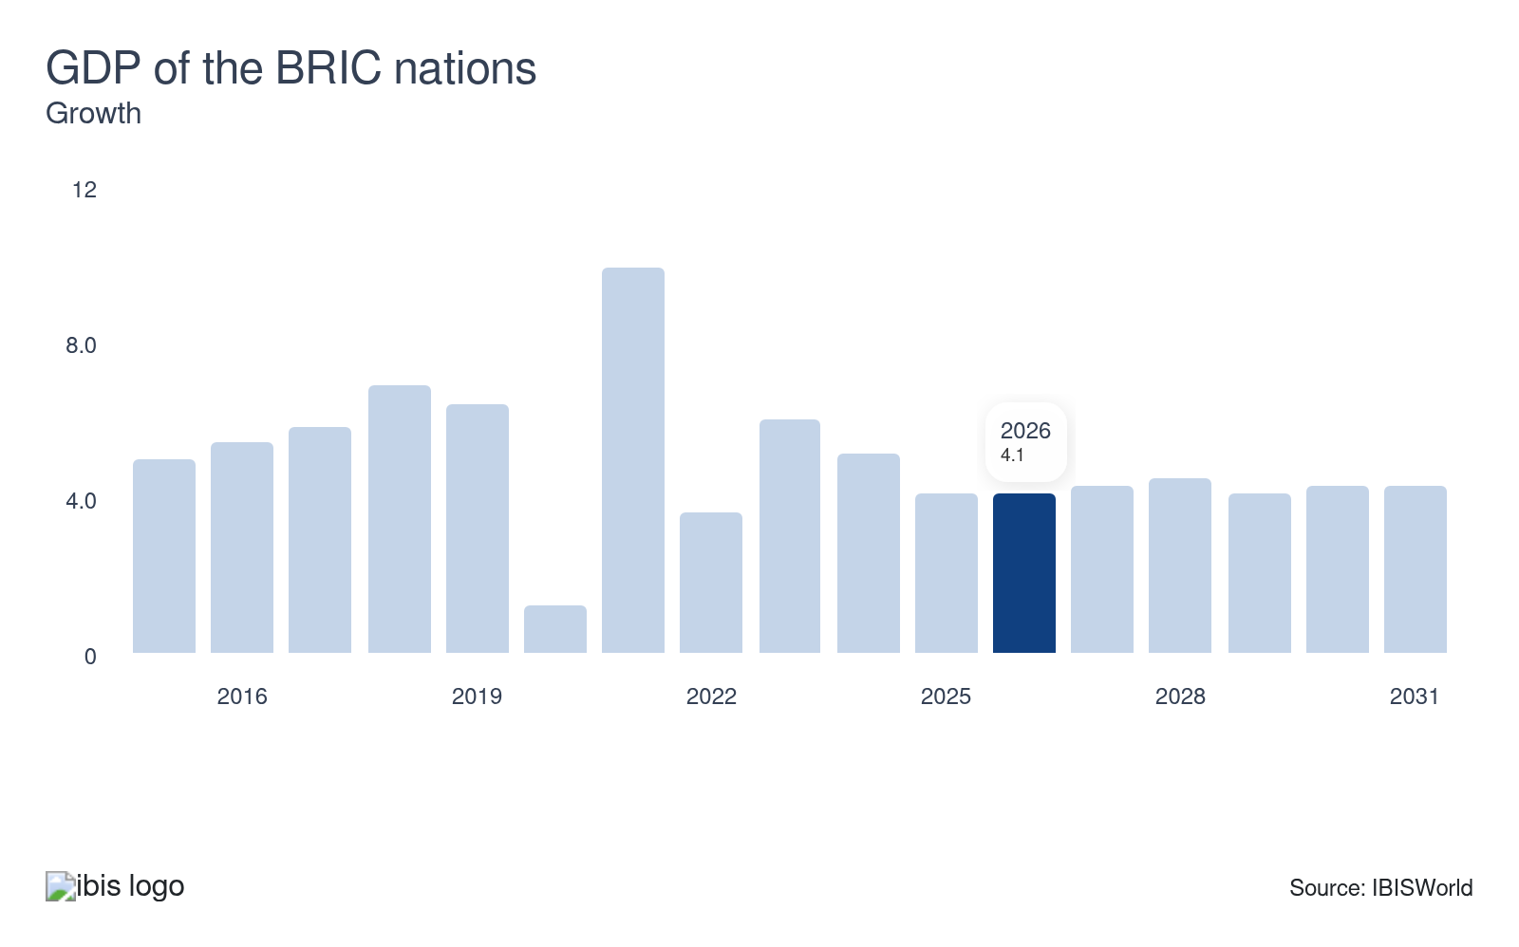
Economic output from Brazil, Russia, India, and China (the BRIC nations) generates some of the world's largest cross-border trade flows. As these economies expand, industrial production and consumer demand grow, driving higher volumes of raw materials and finished goods across international shipping lanes. For an industry handling bulk and container cargo globally, sustained BRIC growth translates into durable throughput gains.

Regulation & Policy

What regulations impact the industry?

Mediterranean Sulphur Emission Control Enforcement
Compliance monitoring obligations for terminal operators in affected regions have widened materially following the May 2025 designation of the Mediterranean Sea as an Emission Control Area (ECA) under the International Maritime Organization's framework, requiring all vessels in those waters to use fuel with a sulfur content below 0.10%. Alongside this, new ECAs in the Canadian Arctic and the Norwegian Sea, enforcing tighter nitrogen oxide and sulfur oxide standards, took effect in 2026. Ports across ECA-designated regions, including those at Marseille and Piraeus in the Mediterranean, are obligated to monitor arriving vessels' fuel and are prohibited from permitting scrubber washwater discharge into port waters. These requirements have prompted terminal operators to invest in fuel-testing procedures and additional compliance staffing, adding recurring operational overhead that falls disproportionately on port and harbor operations segments where monitoring responsibility is concentrated.

FuelEU Maritime
Terminal operators serving EU ports face active enforcement obligations under FuelEU Maritime, which entered its first compliance cycle in 2025 and imposes escalating greenhouse gas (GHG) reduction targets on vessels calling at EU ports. Large vessels must meet GHG intensity limits reaching 80% by 2050, with a firm capital deadline requiring passenger and container ships to use shore power or zero-emission alternatives from 2030. Accelerating liquefied natural gas (LNG) vessel adoption among carriers, the regulation is reflected in the LNG-capable tonnage proposed for the Hapag-Lloyd/ZIM merged fleet, while obligating terminal operators to support compliant vessel infrastructure at affected berths. Rotterdam World Gateway committed to equipping its full quayside with shore-based power from 2026 onward, illustrating the capital response the regulation is driving across major EU hub ports.

Assistance

What assistance is available to this industry?

European Union Connecting Europe Facility and AFIF
Together, the EU's Connecting Europe Facility (CEF) Transport programme and its companion Alternative Fuels Infrastructure Facility (AFIF) constitute the most significant public financing mechanism for European port infrastructure. A July 2025 CEF Transport call awarded €2.8 billion across dozens of projects, with port-specific components covering shore-side electricity installations at facilities in Ireland, Cyprus, Malta, Croatia, and Poland (EU CINEA, 2025). Separately, the AFIF, announced November 2025, directed an additional €600.0 million toward alternative fuels infrastructure, with dozens of EU ports receiving funds to deploy onshore power supply systems and ammonia bunkering facilities. For terminal operators across the EU, both programs reduce the capital burden of mandatory decarbonisation investment.

India Sagarmala Programme
India's Sagarmala programme, launched by the Ministry of Ports, Shipping and Waterways, is one of the largest nationally coordinated port development programs currently active. Under Sagarmala 2.0, direct government support of Rs 85,482 crore (approximately $10 billion) aims to catalyse substantially larger total investment across hundreds of projects spanning port modernisation, rail-port connectivity, and coastal economic zones, per India's Ministry of Ports press bureau (2026). Measured in operational terms, vessel turnaround time at major Indian ports fell to 49.5 hours by 2025, roughly halved from 2014 levels, reflecting sustained infrastructure investment that has lifted multiple Indian ports into global top-100 throughput rankings. For terminal operators with Indian facilities or concessions, the programme reduces capital costs and supports throughput growth in one of the fastest-growing port markets globally.

Singapore Maritime Sector Incentive
Singapore's Maritime Sector Incentive (MSI), administered by the Maritime and Port Authority of Singapore (MPA), provides structured tax benefits across three tiers that collectively underpin Singapore's competitive position as the world's leading bunkering and ship registry hub. According to the MPA's 2026 program documentation, the MSI-SSS (Shipping-related Support Services) tier applies a 10% concessionary corporate income tax rate on qualifying maritime services income including ship management, ship broking, and freight forwarding, while MSI-ML (Maritime Leasing) extends concessionary treatment to qualifying leasing income; both tiers carry application deadlines through end-2031. Complementing the incentive regime, the MPA's Maritime Singapore Green Initiative provides S$50 million in green grants supporting terminal operators investing in low-emission port infrastructure, helping offset the capital cost of compliance with tightening IMO and EU decarbonisation standards.

Chinese State-Directed Overseas Port Financing
Chinese state-directed port financing has created a structurally uneven competitive environment for independent terminal operators bidding for concessions across emerging and developed markets. According to the AidData CPORTS 2.0 dataset published by William and Mary University (2026), Chinese state-owned entities delivered nearly $24 billion in loans and grants to ports across 90 countries between 2000 and 2025. Financing reaches high-income markets including Greece, Spain, Australia, and Singapore, and a significant share of projects involve both Chinese ownership and operation, reflecting a state strategy that extends beyond equity investment to operational control. Independent operators, including DP World, PSA International, and CK Hutchison, compete against Chinese-affiliated bidders who can access below-market state financing, compressing the return thresholds at which non-Chinese operators can competitively win concessions in key emerging markets.

Private support doesn't apply to the industry
The Global Marine and Container Terminal Operations industry doesn't receive any private sector assistance.

9. Financial Benchmarks
https://my.ibisworld.com/gl/en/industry/H4913-GL/financial-benchmarks
Profit Margin  15.1 %  ↑ Higher than sector | Average Wage  $38,006  ↓ Lower than sector | Largest Cost  Purchases  33.1% of Revenue

Key Takeaways
- Profit look stable on the surface, but regional shocks are creating bigger splits underneath. Operators exposed to high-risk trade lanes or recent conflicts, such as APM Terminals Bahrain’s Iran-related hit, are seeing outsized profit compression even as global averages appear flat.
- Rising wage costs are quietly reshaping the industry’s cost base as skilled labor remains non-negotiable. Union deals like the International Longshoremen’s Association’s 61.0% cumulative increases and similar premiums elsewhere are locking in structurally higher operating expenses, squeezing profit.

Cost Structure
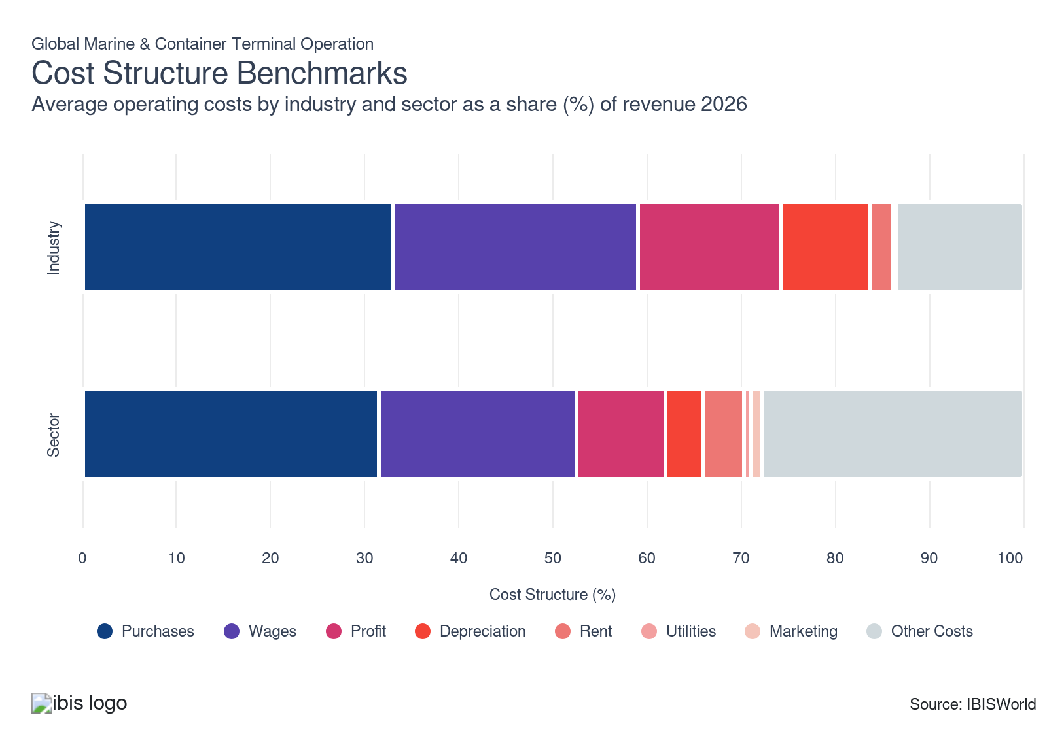
Chart displays current year only in the PDF version of this report. You can view and download chart for all other years associated with this industry on my.ibisworld.com.

What trends impact industry costs?

Profit margins stabilize but mask widening regional splits
- Profit’s share of revenue stayed effectively flat in 2026, with a 0.2% annual uptick that IBISWorld classifies as unchanged. The plateau reflects a cost structure that moved roughly in line with revenue, leaving no single expense category large enough to dilute average profit across global marine and container terminal operators.
- Beneath this stability, profit’s revenue share varies more widely by region and exposure to geopolitical risk. Operators that grew through acquisitions or concentrate on vulnerable trade lanes are seeing sharper margin compression, illustrated by APM Terminals Bahrain reporting a 56.0% profit drop in the first quarter of 2026 because of the Iran conflict, which drags on industrywide averages despite steadier performance elsewhere.

Wage hikes driven by union negotiations increase operating costs
- Wages account for this industry's largest share of operating expenses and that share has risen in recent years. The industry relies on skilled labor for critical roles such as dockworkers, crane operators and logistics support, so employers can’t easily replace labor with automation.
- Unionized bargaining, especially in major North American ports, has guided a sharp upward trend. The International Longshoremen’s Association negotiated cumulative wage increases topping 61.0% for East and Gulf Coast dockworkers starting in 2019. Other regions see similar wage trends as terminals pay premiums to secure scarce labor. This rising wage pressure directly impacts operators’ profit, compelling companies to invest more in wages relative to overall revenue, not just compared with previous years but also with more technology-driven logistics sectors.

Purchase costs climb as terminals scale operations
- Purchases account for a rising share of revenue as companies expand footprints through facility acquisitions and long-term concessions, lifting outlays on land, buildings and related equipment. Larger asset bases have increased maintenance and depreciation burdens, reinforcing upward pressure on purchase costs relative to revenue.
- Investment in ship-to-shore cranes and other heavy equipment has accelerated, with operators funding taller, higher-capacity units to handle ultra-large container vessels, pushing capital-related purchase costs higher as a share of revenue. At APM Terminals, a $55.0 million crane replacement program in late 2024 added 229-foot cranes to serve ULCVs, illustrating how fleet renewal and capacity upgrades have structurally lifted purchase costs worldwide.

Depreciation has eased as a revenue share, though capital intensity relative to the sector remains pronounced
- Depreciation eased by just over a percentage point on a revenue-share basis in 2026, driven by the denominator effect rather than any reduction in capital spending. Existing amortization schedules remained broadly stable while revenue expanded, mechanically reducing the ratio.
- Capital investment at the industry's largest operators has continued, with PSA International's Tuas Phase 2 automation rollout in Singapore among the projects that will add to the depreciation base as assets enter service. Heavy port infrastructure, including quay cranes, ship-to-shore equipment and deep-water berth construction, carries long but asset-intensive amortization profiles that sustain the structural divergence from sector norms.

Long-term concession structures anchor rent costs with minimal near-term volatility
- Rent has edged up 0.1% year-on-year to 2.6% of revenue, consistent with inflation-linked adjustments built into multi-decade concession agreements rather than any genuine repricing pressure. Port authorities typically set fixed terms spanning 20 to 35 years, with rent resets tied to CPI or throughput thresholds rather than spot market conditions. Extending through 2062 at the Port of New York and New Jersey, Maersk's recent agreement illustrates how operators actively lock in long-horizon certainty over cost flexibility.
- Operators owning land or holding long-term ground leases at below-market historical rents carry a meaningfully lower occupancy cost burden than logistics peers leasing short-cycle warehouse and distribution space at current market rates.

Utility costs remain a minimal expense as energy-efficiency investment keeps consumption contained
- Utility spending has held flat as a share of revenue, with ongoing efficiency investment preventing any increase despite throughput growth. Terminals running automated yard vehicles, LED-lit operations and real-time energy scheduling systems have compressed energy consumption per container handled, allowing utility expenditure to climb at a rate below revenue.
- Progressive adoption of energy-saving infrastructure has left its mark. Major investments, such as Maersk’s deployment of Star Cool 1.1 reefers, which present 8.0% lower energy usage over traditional models, helped bend cost curves. Reefers now let cargo transition through terminals using far less power, enabling terminals and customers in the broader cold chain industry to avoid added charges while in temporary storage. Terminal utility revenue share keeps trending downward as these smart operational upgrades become widespread.

Marketing outlays remain negligible as long-term carrier relationships remove the need for promotional spend
- Marketing costs have held flat. The terminal operating business model is built around multi-year service agreements with shipping lines, freight forwarders and bulk commodity exporters, repeat clients whose procurement decisions rest on operational reliability, berth availability and throughput capacity rather than promotional engagement. Relative to the capital commitment required to win a major concession, customer acquisition costs are negligible.
- Participation in biennial industry conferences such as TOC Europe represents the primary marketing outlay for most operators. This expenditure is controlled and predictable and does not scale with revenue or volume. As long as the industry remains concentrated among a relatively small number of global shipping lines and top alliance groupings, the need for broad marketing activity remains structurally limited.
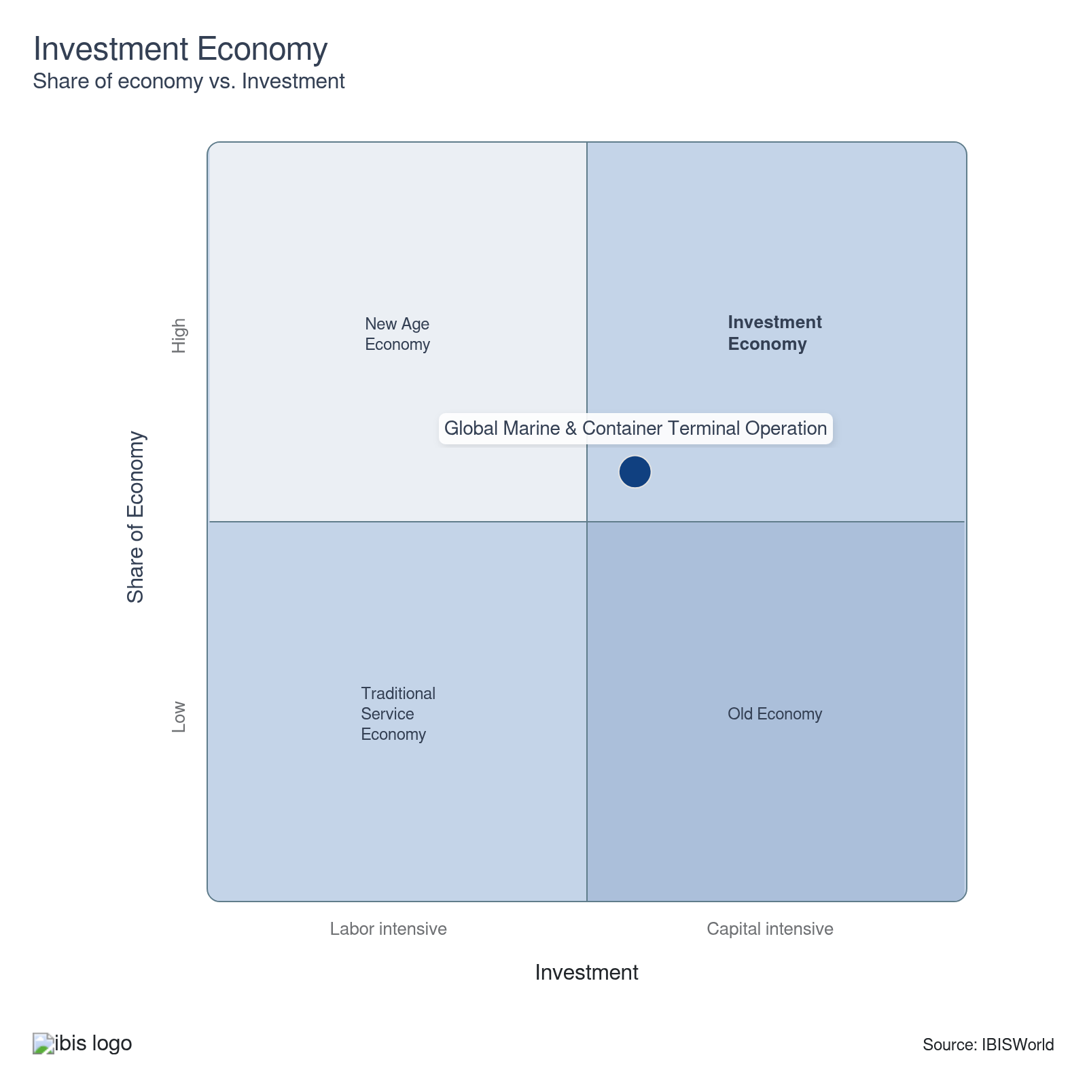

Key Ratios
Year | Revenue per Employee  ($) | Revenue per Enterprise  ($ Million) | Employees per Estab.  (Units) | Employees per Enterprise  (Units) | Average Wage  ($) | Wages/ Revenue  (%) | Estab. per Enterprise  (Units) | IVA/ Revenue  (%)
2006 | 102,295 | 67.7 | 74.8 | 661.8 | 18,825 | 18.4 | 8.8 | 42.7
2007 | 116,583 | 72.9 | 72.5 | 624.9 | 19,049 | 16.3 | 8.6 | 39.5
2008 | 135,338 | 70.3 | 66.2 | 519.2 | 20,187 | 14.9 | 7.8 | 37.3
2009 | 126,008 | 58.2 | 57.9 | 462.3 | 19,465 | 15.4 | 8.0 | 37.1
2010 | 139,300 | 56.9 | 58.1 | 408.4 | 20,505 | 14.7 | 7.0 | 41.6
2011 | 152,614 | 59.0 | 53.7 | 386.5 | 21,977 | 14.4 | 7.2 | 39.4
2012 | 165,765 | 91.3 | 79.3 | 550.8 | 23,856 | 14.4 | 6.9 | 40.1
2013 | 149,726 | 68.7 | 66.7 | 458.6 | 19,947 | 13.3 | 6.9 | 35.9
2014 | 143,805 | 61.3 | 66.6 | 426.0 | 20,321 | 14.1 | 6.4 | 37.1
2015 | 138,009 | 59.3 | 68.5 | 429.6 | 20,970 | 15.2 | 6.3 | 37.2
2016 | 137,678 | 54.4 | 65.7 | 395.3 | 21,476 | 15.6 | 6.0 | 35.9
2017 | 140,142 | 51.5 | 66.5 | 367.6 | 23,646 | 16.9 | 5.5 | 39.7
2018 | 133,688 | 48.7 | 75.8 | 364.5 | 25,235 | 18.9 | 4.8 | 39.1
2019 | 129,638 | 44.1 | 74.9 | 340.5 | 29,122 | 22.5 | 4.5 | 45.1
2020 | 120,119 | 39.1 | 74.2 | 325.9 | 31,822 | 26.5 | 4.4 | 48.6
2021 | 141,444 | 47.5 | 82.5 | 335.8 | 32,107 | 22.7 | 4.1 | 53.5
2022 | 144,188 | 55.4 | 94.8 | 384.3 | 37,897 | 26.3 | 4.1 | 59.9
2023 | 144,136 | 56.1 | 96.4 | 389.2 | 37,896 | 26.3 | 4.0 | 51.8
2024 | 144,848 | 57.6 | 98.9 | 397.5 | 37,934 | 26.2 | 4.0 | 53.3
2025 | 144,625 | 58.5 | 100.9 | 404.3 | 37,923 | 26.2 | 4.0 | 51.7
2026 | 146,236 | 60.6 | 103.5 | 414.5 | 38,006 | 26.0 | 4.0 | 50.5
2027 | 145,731 | 61.2 | 105.0 | 420.1 | 37,980 | 26.1 | 4.0 | 50.6
2028 | 145,674 | 62.4 | 107.0 | 428.0 | 37,977 | 26.1 | 4.0 | 50.6
2029 | 145,668 | 63.3 | 108.5 | 434.5 | 37,976 | 26.1 | 4.0 | 50.8
2030 | 146,350 | 64.4 | 109.8 | 439.8 | 38,012 | 26.0 | 4.0 | 50.9
2031 | 146,958 | 65.4 | 110.9 | 444.7 | 38,044 | 25.9 | 4.0 | 50.8
2032 | 147,575 | 66.3 | 112.0 | 449.5 | 38,076 | 25.8 | 4.0 | 50.7
*Figures are inflation adjusted to 2026
*Figures are inflation adjusted to 2026

10. Key Statistics
https://my.ibisworld.com/gl/en/industry/H4913-GL/key-statistics

Industry Data

Values
Year | Revenue  ($ Million) | IVA  ($ Million) | Estab.  (Units) | Enterprises  (Units) | Employment  (Units) | Wages  ($ Million)
2006 | 42,107.0 | 17,982.8 | 5,502 | 622 | 411,623 | 7,748.7
2007 | 50,925.0 | 20,121.6 | 6,029 | 699 | 436,815 | 8,321.0
2008 | 57,968.0 | 21,619.6 | 6,474 | 825 | 428,321 | 8,646.7
2009 | 49,919.2 | 18,534.7 | 6,838 | 857 | 396,158 | 7,711.3
2010 | 54,162.4 | 22,537.7 | 6,689 | 952 | 388,818 | 7,972.7
2011 | 63,167.4 | 24,896.2 | 7,711 | 1,071 | 413,903 | 9,096.3
2012 | 65,373.0 | 26,237.2 | 4,971 | 716 | 394,371 | 9,408.1
2013 | 67,289.1 | 24,141.5 | 6,733 | 980 | 449,416 | 8,964.5
2014 | 68,236.9 | 25,282.7 | 7,126 | 1,114 | 474,510 | 9,642.4
2015 | 67,003.1 | 24,910.0 | 7,086 | 1,130 | 485,499 | 10,180.8
2016 | 64,932.1 | 23,336.3 | 7,182 | 1,193 | 471,624 | 10,128.8
2017 | 65,068.2 | 25,838.8 | 6,983 | 1,263 | 464,303 | 10,978.9
2018 | 67,886.2 | 26,574.1 | 6,701 | 1,393 | 507,796 | 12,814.2
2019 | 66,219.5 | 29,842.6 | 6,819 | 1,500 | 510,802 | 14,875.7
2020 | 60,639.6 | 29,481.0 | 6,804 | 1,549 | 504,831 | 16,064.9
2021 | 76,461.0 | 40,913.6 | 6,550 | 1,610 | 540,575 | 17,356.3
2022 | 87,605.6 | 52,462.6 | 6,412 | 1,581 | 607,578 | 23,025.6
2023 | 88,908.0 | 46,056.4 | 6,396 | 1,585 | 616,832 | 23,375.3
2024 | 92,015.4 | 49,026.5 | 6,424 | 1,598 | 635,256 | 24,097.8
2025 | 93,853.8 | 48,531.8 | 6,430 | 1,605 | 648,944 | 24,609.6
2026 | 99,215.5 | 50,055.7 | 6,555 | 1,637 | 678,462 | 25,785.6
2027 | 100,537.3 | 50,853.6 | 6,568 | 1,642 | 689,885 | 26,201.6
2028 | 103,133.3 | 52,158.7 | 6,617 | 1,654 | 707,975 | 26,886.6
2029 | 105,750.6 | 53,684.3 | 6,690 | 1,671 | 725,968 | 27,569.7
2030 | 109,288.0 | 55,660.0 | 6,804 | 1,698 | 746,759 | 28,385.8
2031 | 113,006.1 | 57,427.6 | 6,933 | 1,729 | 768,970 | 29,254.4
2032 | 116,956.3 | 59,341.4 | 7,076 | 1,763 | 792,522 | 30,175.7

*Figures are inflation adjusted to 2026

Annual Change
Year | Revenue  % | IVA  % | Estab.  % | Enterprises  % | Employment  % | Wages  %
2006 | N/A | N/A | N/A | N/A | N/A | N/A
2007 | 20.9 | 11.9 | 9.6 | 12.4 | 6.1 | 7.4
2008 | 13.8 | 7.4 | 7.4 | 18.0 | -1.9 | 3.9
2009 | -13.9 | -14.3 | 5.6 | 3.9 | -7.5 | -10.8
2010 | 8.5 | 21.6 | -2.2 | 11.1 | -1.9 | 3.4
2011 | 16.6 | 10.5 | 15.3 | 12.5 | 6.5 | 14.1
2012 | 3.5 | 5.4 | -35.5 | -33.1 | -4.7 | 3.4
2013 | 2.9 | -8.0 | 35.4 | 36.9 | 14.0 | -4.7
2014 | 1.4 | 4.7 | 5.8 | 13.7 | 5.6 | 7.6
2015 | -1.8 | -1.5 | -0.6 | 1.4 | 2.3 | 5.6
2016 | -3.1 | -6.3 | 1.4 | 5.6 | -2.9 | -0.5
2017 | 0.2 | 10.7 | -2.8 | 5.9 | -1.6 | 8.4
2018 | 4.3 | 2.8 | -4.0 | 10.3 | 9.4 | 16.7
2019 | -2.5 | 12.3 | 1.8 | 7.7 | 0.6 | 16.1
2020 | -8.4 | -1.2 | -0.2 | 3.3 | -1.2 | 8.0
2021 | 26.1 | 38.8 | -3.7 | 3.9 | 7.1 | 8.0
2022 | 14.6 | 28.2 | -2.1 | -1.8 | 12.4 | 32.7
2023 | 1.5 | -12.2 | -0.2 | 0.3 | 1.5 | 1.5
2024 | 3.5 | 6.4 | 0.4 | 0.8 | 3.0 | 3.1
2025 | 2.0 | -1.0 | 0.1 | 0.4 | 2.2 | 2.1
2026 | 5.7 | 3.1 | 1.9 | 2.0 | 4.5 | 4.8
2027 | 1.3 | 1.6 | 0.2 | 0.3 | 1.7 | 1.6
2028 | 2.6 | 2.6 | 0.7 | 0.7 | 2.6 | 2.6
2029 | 2.5 | 2.9 | 1.1 | 1.0 | 2.5 | 2.5
2030 | 3.3 | 3.7 | 1.7 | 1.6 | 2.9 | 3.0
2031 | 3.4 | 3.2 | 1.9 | 1.8 | 3.0 | 3.1
2032 | 3.5 | 3.3 | 2.1 | 2.0 | 3.1 | 3.1

*Figures are inflation adjusted to 2026

DISCLAIMER
This product has been supplied by IBISWorld Inc. (‘IBISWorld’) solely for use by its authorized licenses strictly in accordance with their license agreements with IBISWorld. IBISWorld makes no representation to any other person with regard to the completeness or accuracy of the data or information contained herein, and it accepts no responsibility and disclaims all liability (save for liability which cannot be lawfully disclaimed) for loss or damage whatsoever suffered or incurred by any other person resulting from the use of, or reliance upon, the data or information contained herein. Copyright in this publication is owned by IBISWorld Inc. The publication is sold on the basis that the purchaser agrees not to copy the material contained within it for other than the purchasers own purposes. In the event that the purchaser uses or quotes from the material in this publication – in papers, reports, or opinions prepared for any other person – it is agreed that it will be sourced to: IBISWorld Inc.

